Technical Manual

RadPortal

Developed By -
Miracle Advance Technology

Last Update Date -
12/22/2022

This Document Is for the RadPortal Application
Version – 1.1.1

Written By -
S. M. Al Shahaneaz Shaikat

Revision Sheet

Release No. | Date | Revision Description | Author Name
Rev. 1.1.1 | 22/12/22 | Add Medical licence while signing up, Radiologist Dashboard | S M Al Shahaneaz Shaikat
Rev. 2 | DD/MM/YY | Short description of Major changes | Name
Rev. 3 | DD/MM/YY | Short description of Major changes | Name
Rev. 4 | DD/MM/YY | Short description of Major changes | Name

USER'S MANUAL OF RADPORTAL

Table of Contents

1. General Information about RadPortal 5
1.1 System Overview 5
1.2 Project References 6
1.3 Organization of the Manual 6
1.4 Acronyms and Abbreviations 6
1.5 Additional Help 7
2. System Summary 7
2.1 Minimum Hardware Requirements, Supported Browsers List, And Operating System List for RadPortal 7
2.1.1 Hardware Requirements Personal Computers and Laptops: 7
2.1.2 Browsers: 8
2.1.3 Operating System: 8
2.2 User Roles and Permission Levels 8
2.2.1 Service Provider(Admin) 8
2.2.2 Customer 9
2.2.3 Hospitals(Healthcare Service Provider) 9
2.2.4 Radiologist(Subject Matter Experts) 9
2.2.5 Viewer 9
3. Getting Started 9
3.1 Signing Up 10
3.2 Logging In 14
3.3 System Menus 16
3.4 How to Change Password, Change Profile Picture, and Add Your Digital Signature 17
3.4.1 Changing Password 17
3.4.2 Changing Profile Photo 18
3.4.3 Adding Digital Signature 19
3.5 Sign Out from The System 21
4. Exploring Dashboard 23
5. Exploring Worklist Menu 25
5.1 How to Search Studies 26
5.2 How to Sort Studies 27
5.3 How to view Images, Decline Cases, write Reports, and View Documents Additional Documents of Studies 28
5.3.1 Review Images of a Specific Study 28
5.3.2 How to Decline Assigned Studies 30
5.3.3 How to View Additional Documents of a Study 31
5.3.4 How to Write Reports and Finalize Reports 32
5.3.5 View Study Reports 37
5.3.6 Adding an Addendum 38

1. General Information about RadPortal

Radportal is a Secured cloud-based radiology platform. The main problem it solves is that there are many hospitals in remote places worldwide with all the modern medical equipment for medical tests such as (MRI, CT scan, x-rays, nuclear medicine, ultrasound, and more). Still, hospitals may not have expert radiologists/doctors readily available to write the reports for these studies when patients come to these remote hospitals and complete their tests.
Sometimes the Patient has to physically go to hospitals/Other more developed cities where radiologists/Doctors are available, but this process is difficult and time-consuming.
Using the RadPortal System, the hospital can easily save patient test results. Then the hospitals can forward the test results to an expert doctor/radiologist who may not live nearby.

System Overview
RadPortal is a secured cloud-based radiology platform. It helps hospitals to send their Patient's radiology test images to doctors/radiologists worldwide and receive written reports from remote doctors/radiologists.
RadPortals Core functionalities are
- All hospitals/sites that have already configured modality devices can automatically send DICOM files to their routers, which are then forwarded to the RadPortal cloud database.

- RadPortal system reads the DICOM headers and collects Information from the header, and saves it as an entity called "study".

- Hospitals also can upload single or multiple DICOM files manually.

- Hospitals can then access DICOMs from their RadPortal profiles and assign specific radiologists to write reports on that particular study or keep the study open for other radiologists.

- Suppose any open study is available on RadPortal. In that case, the independent radiologists can log in to their RadPortal profiles and independently select any open study. Then the individual Radiologist can write reports for that particular study.

- The Radiologist has a roaming profile, so they do not need specific devices to interact with the RadPortal system. The Radiologist can interact with the RadPortal system with laptops, desktops, or tabs and a reliable Internet connection.

- RadPortal also helps Government Institutes such as the National Health Security office to track the number of studies and reports the hospitals and the radiologists completed and disburse fees and payments accordingly.

Project References
References used in preparing this document are listed here. Project References may help you understand the complex topics and terms used in the RadPortal system.

http://dicomlookup.com/modalities.asp

1.3 Organization of the Manual
This document is patterned to familiarize you with the core functionalities of the RadPortal application. This document explains how the application is intended to use by properly explaining its functionalities and limitations.
You will also know how the RadPortal application saves Information and how the Information is shared across multiple user roles within the RadPortal system. We will discuss the most common elements so readers can later relate to the terms as they look deeper into the application's features and functionalities.
The functionalities will vary depending on user roles, but the role Admin will have access to all the functionalities of RadPortal. User roles are extensively explained in section 2.2, User Roles and Permission Levels.

1.4 Acronyms and Abbreviations
Common acronyms and abbreviations are introduced in this section so the reader can get comfortable with the acronyms and abbreviations used in this documentation and the RadPortal application.
DICOM Digital Imaging and Communications in Medicine.
PACS Picture archiving and communication system.

1.5 Additional Help
Common terms are introduced throughout the user manual to familiarize the reader with the common terms used in the application. Sections are indexed(numbered, bullet points, and roman numbers). Sections are also linked to common keywords so the reader can go directly to any relevant section to find more Information. For easier navigation, keywords are marked in blue.
Here are the styles used for lists
Bulleted lists:
- Text 1
- Text 2
- Text 3
Numerical numbered lists:
- Text 1
- Text 2
- Text 3
Roman numbered lists:
- Text 1
- Text 2
- Text 3

Here are the styles for Notes and warnings.
Note: Notes are marked in the color blue.

Warning: Warning messages are marked in the color red.

2. System Summary

2.1 Minimum Hardware Requirements, Supported Browsers List, And Operating System List for RadPortal

2.1.1 Hardware Requirements Personal Computers and Laptops:
- Processor (CPU) with 2 gigahertz (GHz) frequency or above
- A minimum of 2 GB of RAM
- Monitor Resolution 1024 X 768 or higher
- A minimum of 20 GB of available space on the hard disk
- Stable internet connection with a speed of 4 megabits per second or higher
- Keyboard and mouse or compatible pointing device

2.1.2 Browsers:
- Chrome 36+
- Edge 20+
- Mozilla Firefox 31+
- Internet Explorer 11+ (Windows only)
- Safari 6+ (macOS only)

2.1.3 Operating System:
- Windows 7, Windows 8, Windows 10, or Windows 11
- Mac OSX 10.8, 10.9, 10.10, or 10.11

2.2 User Roles and Permission Levels
Before we look deeper into the RadPortal system, you must understand the user roles properly. The user roles are listed below.
- Service Provider (Admin)
- Customer
- Hospitals (Health Service Providers)
- Radiologists (Subject Matter Experts)
- Viewer

2.2.1 Service Provider(Admin)
Miracle Advance Technology is the service provider, and Miracle Advance Technology plays the Administration role inside the RadPortal System. The main functionality of an administrator role is to manage the system so that the system runs smoothly and without errors. For the RadPortal system, the Service Provider will also install, configure and manage DICOM routers for hospitals.

2.2.2 Customer
This role is very important in the RadPortal system. The only customer role can Configure Turnaround Time and manage and verify Radiologists. They also have full control over the RadPortal system. The Customer is also in charge of disbursing Fees and payments to the Hospitals and Radiologists.

2.2.3 Hospitals(Healthcare Service Provider)
Hospitals are also called "sites" in the RadPortal system. Hospitals play an significant role in the RadPortal System. They have to perform medical tests such as (MRI, CT scan, x-rays, nuclear medicine, ultrasound, and more) and manually upload files and images from browsers or the modality devices can automatically send DICOM files to RadPortal servers to create cases which are also called studies. The hospital can access the files, images, and DICOMs uploaded to the RadPortal server.

2.2.4 Radiologist(Subject Matter Experts)
The Radiologist also plays a significant role in the RadPortal System. There are two types of radiologist roles in the RadPortal system.
- Normal Radiologists
- Supervisor Radiologist
The main difference between the Supervisor and a normal Radiologist is that a Supervisor Radiologist can view all cases or studies, and a normal radiologist can only see the studies/cases they are assigned to. Only the verified normal Radiologist can write reports of submitted cases.

2.2.5 Viewer
The Viewer role is a bit unique. The viewer does not interact with any aspects of the RadPortal system. The viewers only view how many cases/studies the hospital/sites completed and how many reports the radiologists submitted and finalized in the RadPortal system.
This role is given to people/organizations with the authority to monitor and audit the RadPortal system. This role is also given to the government institutes that might want to monitor the whole RadPortal system.

3. Getting Started
Signup and Login Workflow
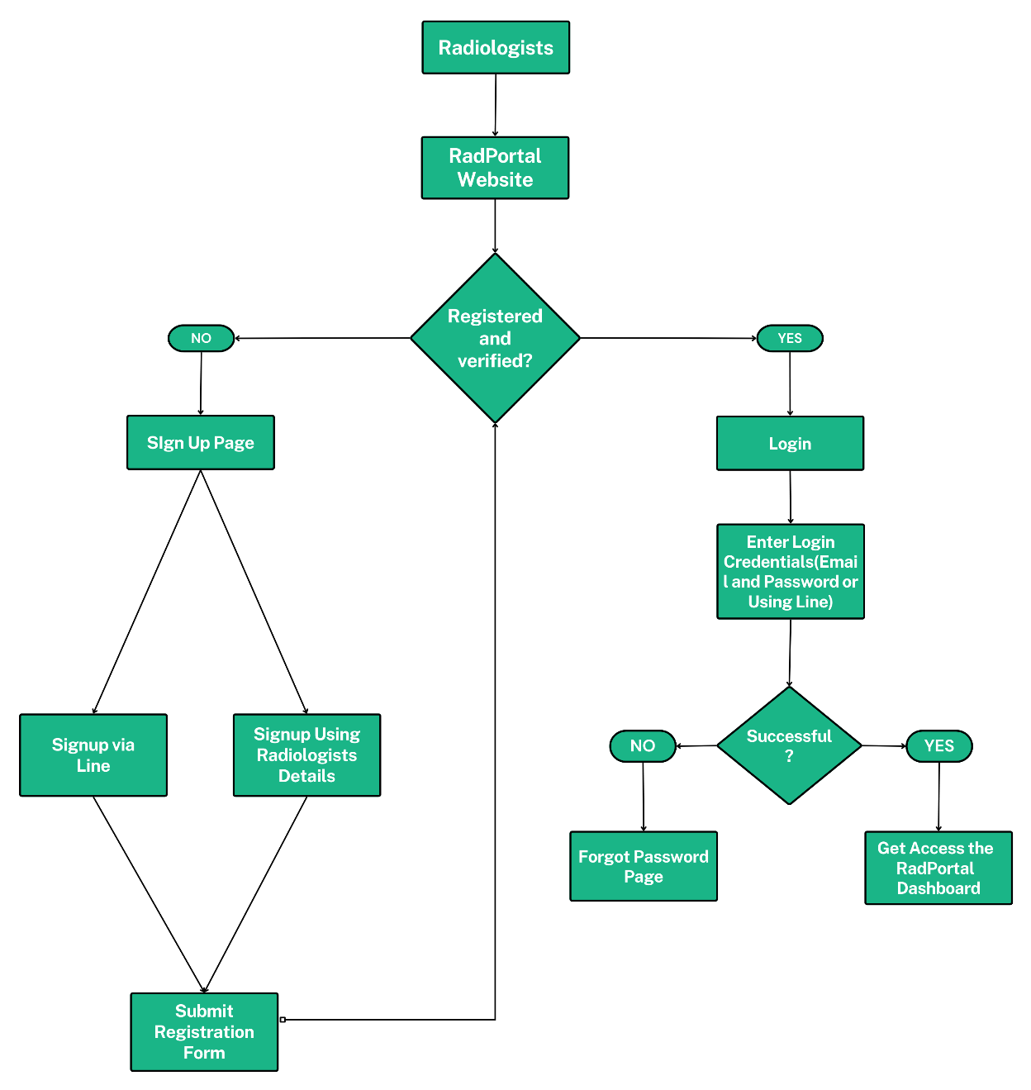

3.1 Signing Up
Before using the RadPortal system, you have to sign up as a Radiologist. To sign up as a radiologist, you have to go to this URL - https://radportal.net.
After the website loads, you should see a page like this.
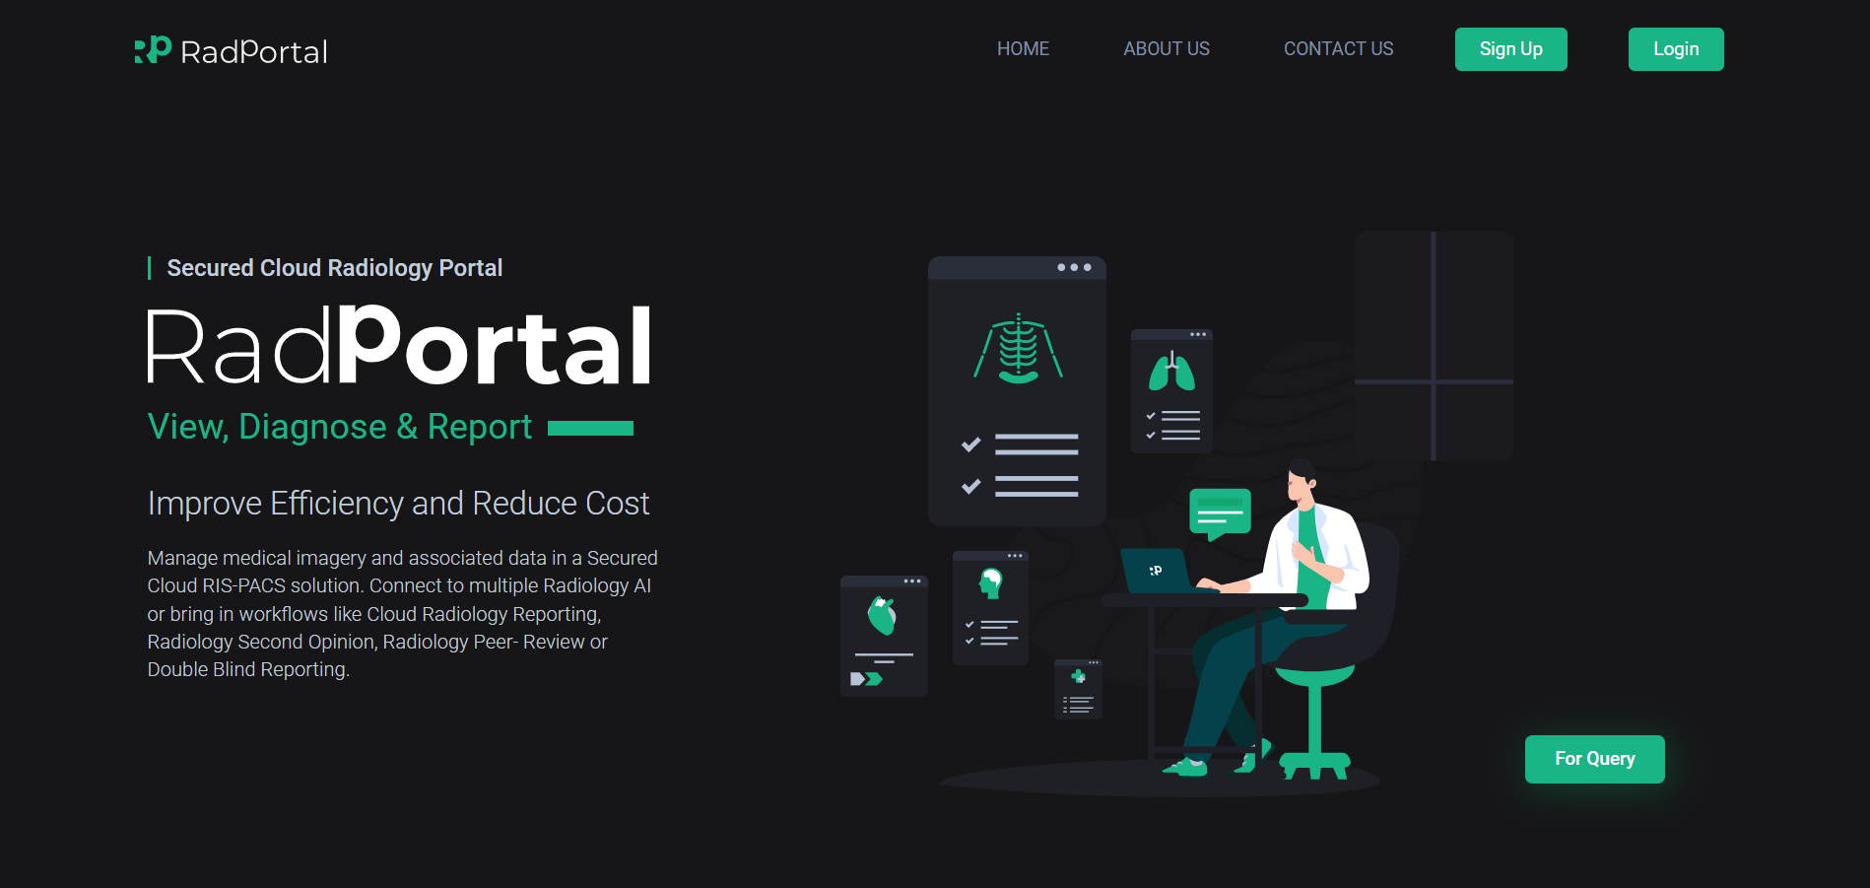

To sign up as a radiologist, click on the Sign-Up button.
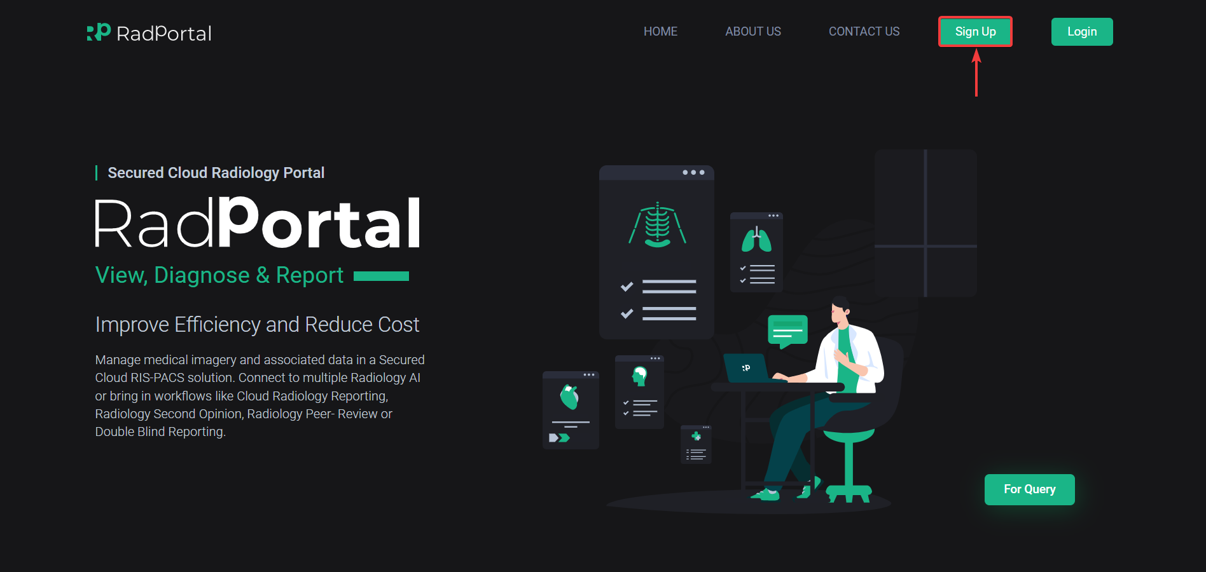

After clicking, you should see a page where you have to click on the Sign up as a Radiologist button.
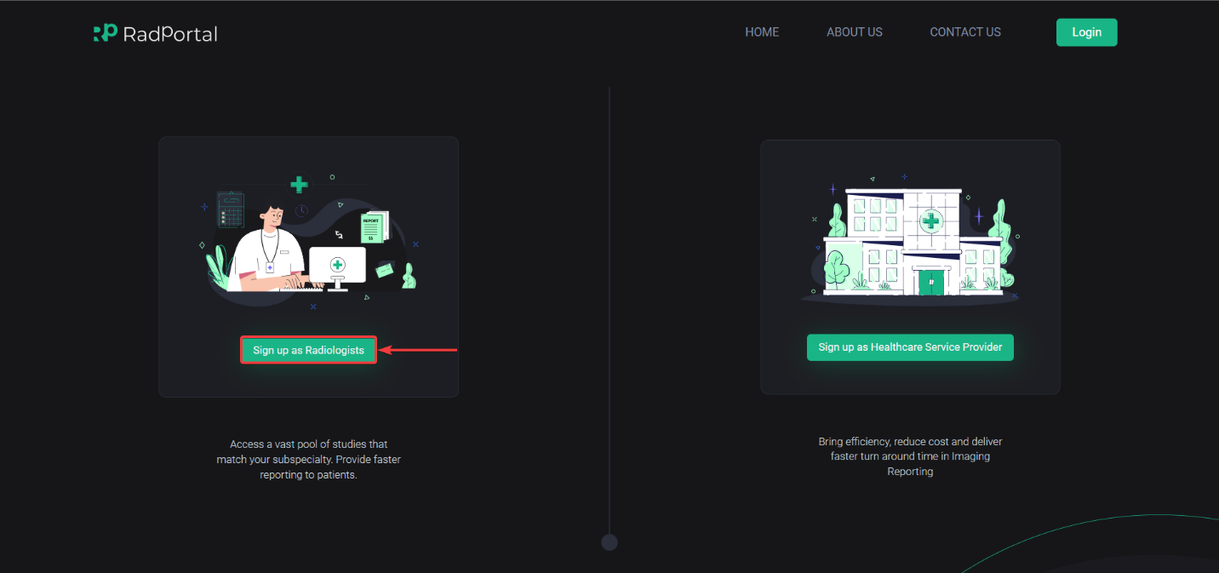

Now you will be forwarded to the Radiologist sign-up page, where you have to sign up using your Email [1] and Phone number [2] and agree to our Account Terms of Use by clicking on the Checkbox [3]. Finally, click on the Send Verification code [4] button.
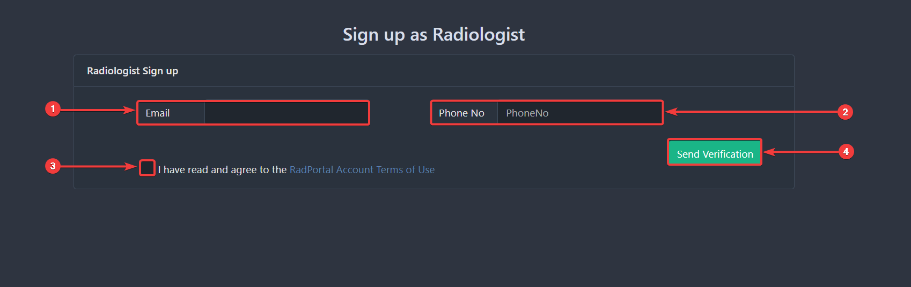

After clicking, you should see two sections pop up under the Email and Phone Number section, where you have to enter the OTP code you received on your email address and phone number.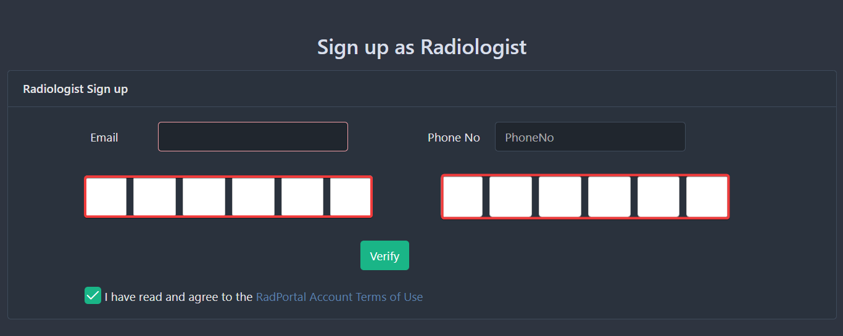

After you complete your verification process, you can move forward to the next section, where you have to fill in your Password [1], Confirm Password [2], First Name [3], Last Name [4], Line ID [5], Country [6], District [7], Province [8], Sub-District [9], Zip Code [10], Subspecialties [11], upload your profile picture by clicking on Choose [12], Upload any relevant documents by clicking on Upload Document [13]. To start the signing-up process from the start, click on the Start Over [14] button. Finally, click on Finish [15] to complete your sign-up process.
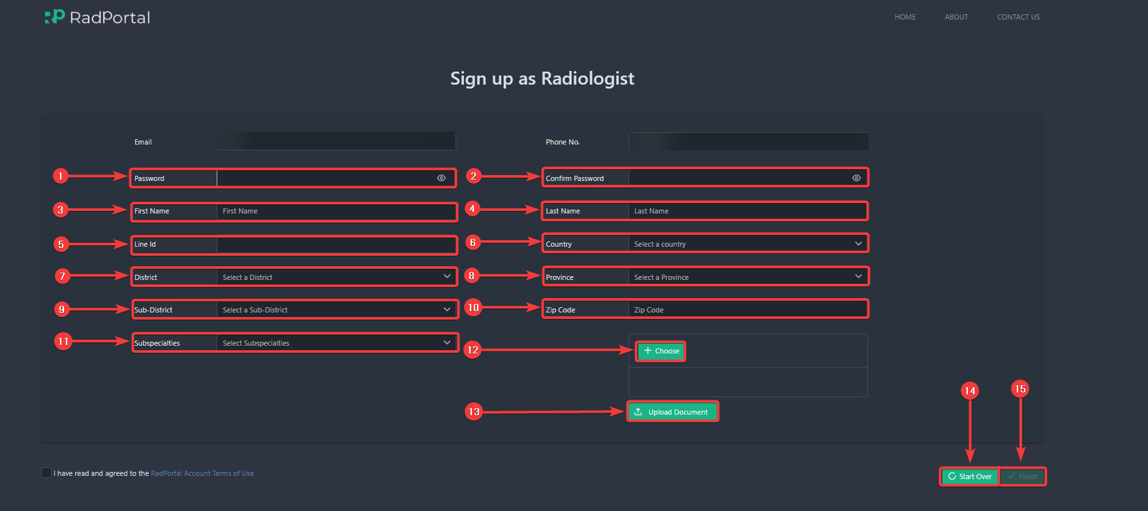

After you successfully signed up to the RadPortal system. You have to wait a certain period to get verified by our system. All of your documents will be manually verified. After your details are verified, you should receive a welcome email from our end.

3.2 Logging In
You will be able to log in. To log in, you have to go to this URL – https://app.radportal.net/#/login. After the login page loads, you should see a page like this
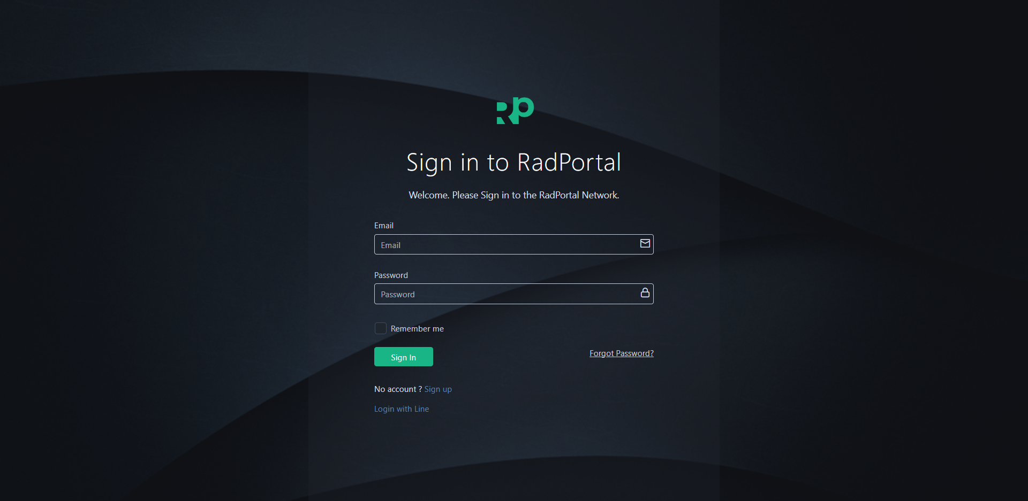

After you access the login page, you can use your Email [1] and Password [2] to log in to the RadPortal. You have to use the login credentials you used to create your account. Finally, click on the Sign In [3] button.
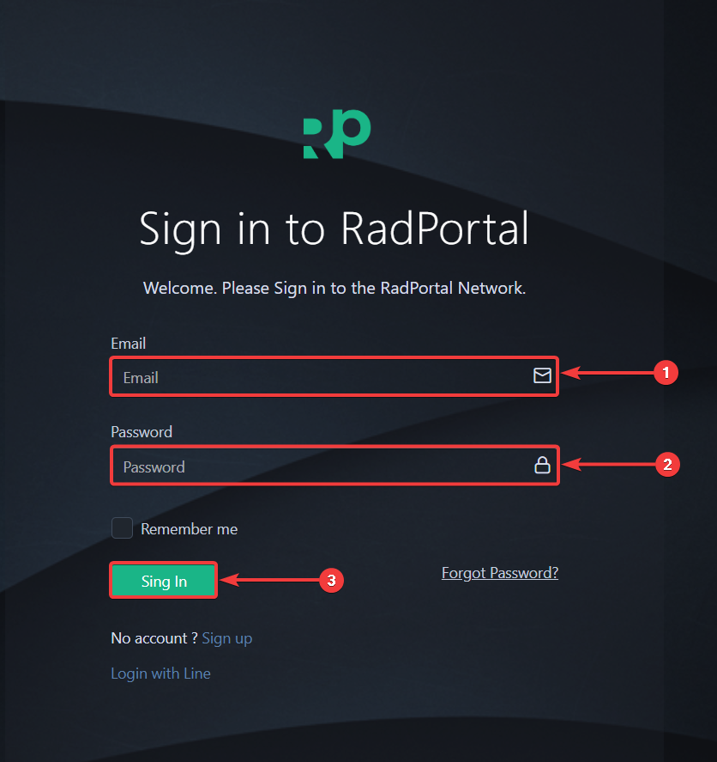

After successfully logging in, you should see the dashboard page of RadPortal.
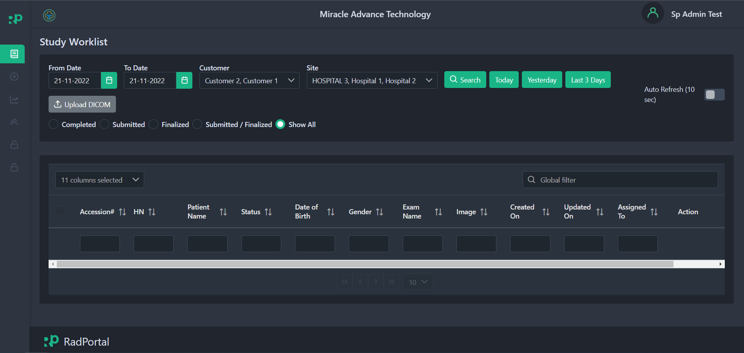

3.3 System Menus
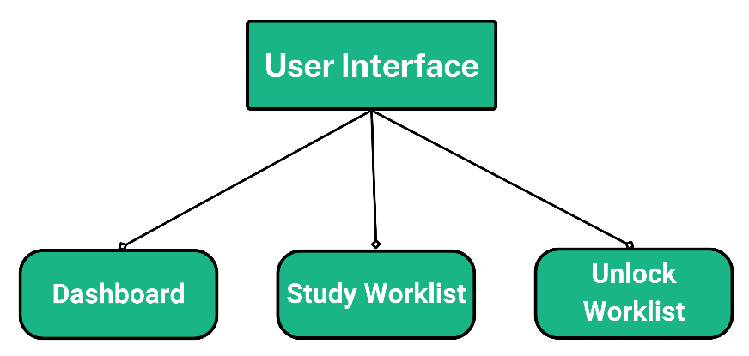

The RadPortal system has these menus currently available for Radiologists
- Dashboard
- Worklist
- Unlock Worklist

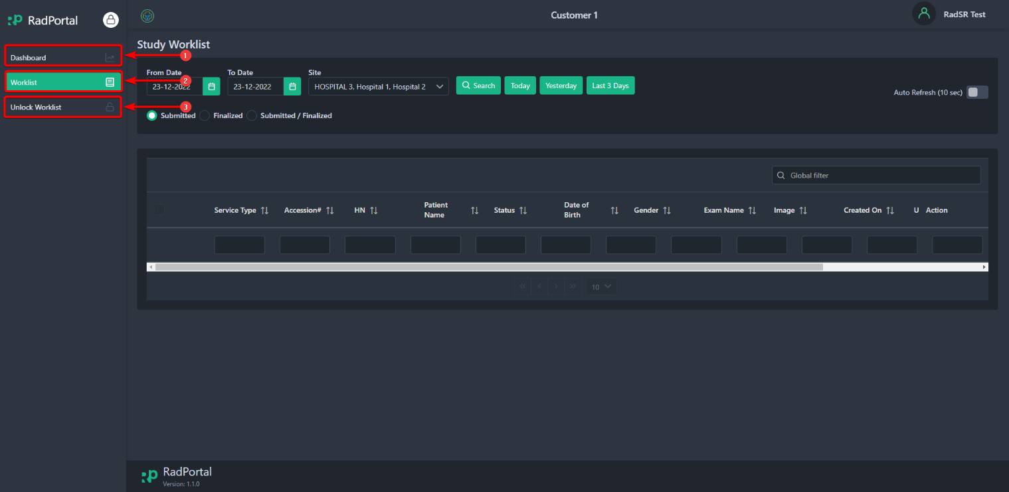

3.4 How to Change Password, Change Profile Picture, and Add Your Digital Signature

3.4.1 Changing Password
You can easily change your RadPortal login password from your profile. To access your profile, click on your username [1] in the top right corner and click on Profile [2].

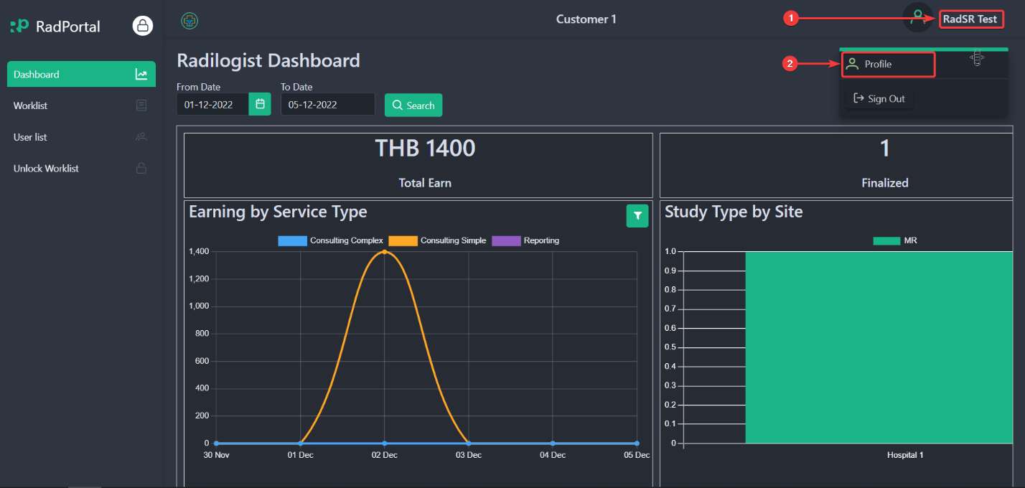

After clicking on The Profile, the system will redirect you to your profile page. On this page, you can change your Password. To change your user Password, click on the Change User Password button.
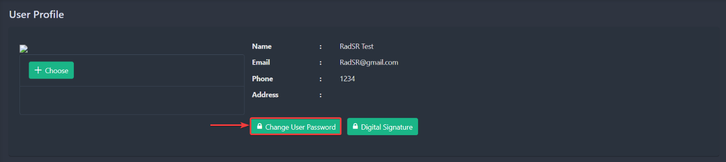

After clicking, you should see a new page where you have to confirm your Old Password [1], enter your New Password [2], and confirm your new Password [3]. Click on the Update button [4] to finalize your new password setup.
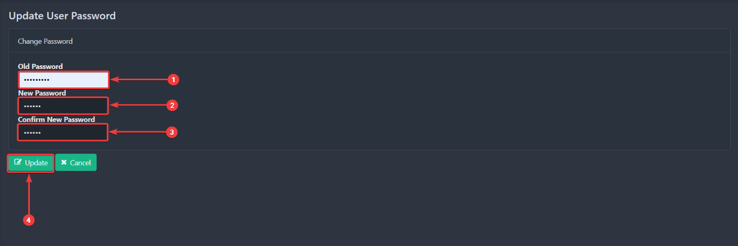

3.4.2 Changing Profile Photo
To change your profile photo, go back to your profile again and click on the Choose button.
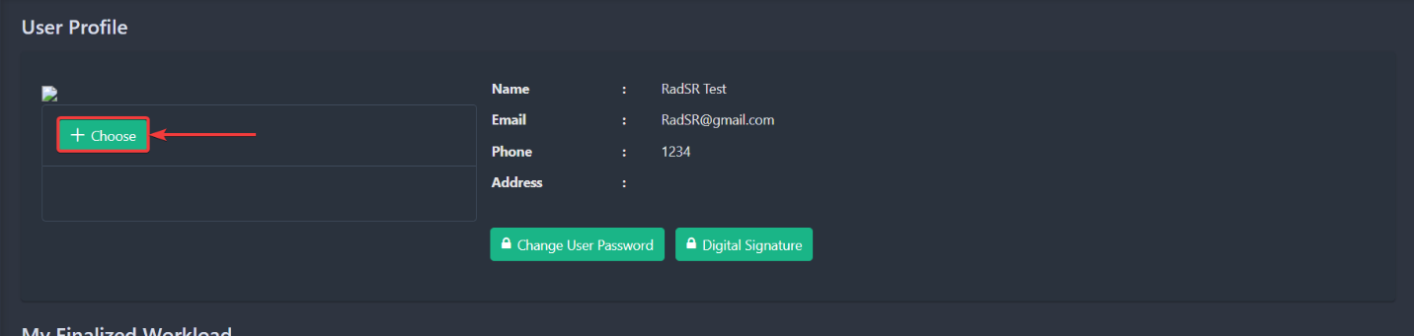

After clicking on the button, you can choose a photo for your profile. You can select your photos directly from your computer. After you upload your profile photo, you will see the preview in the section below.
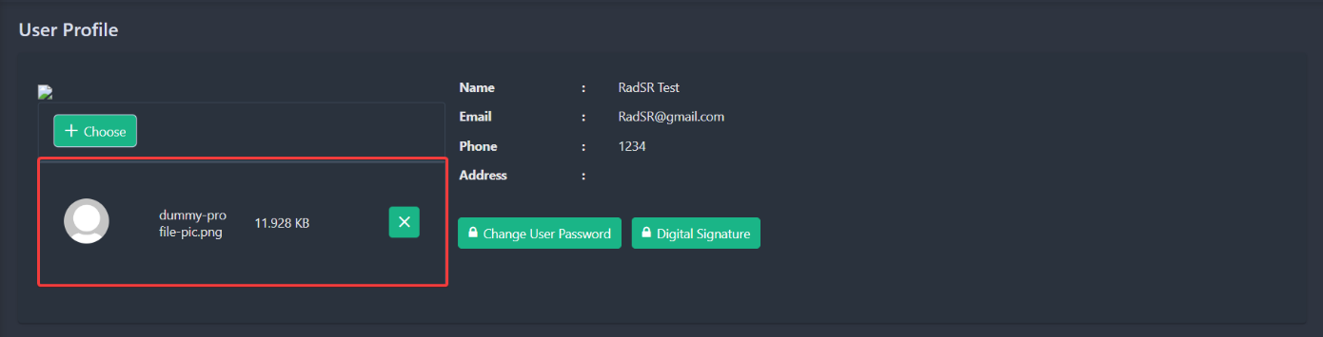

You can remove the photo by clicking on the green cross Icon.
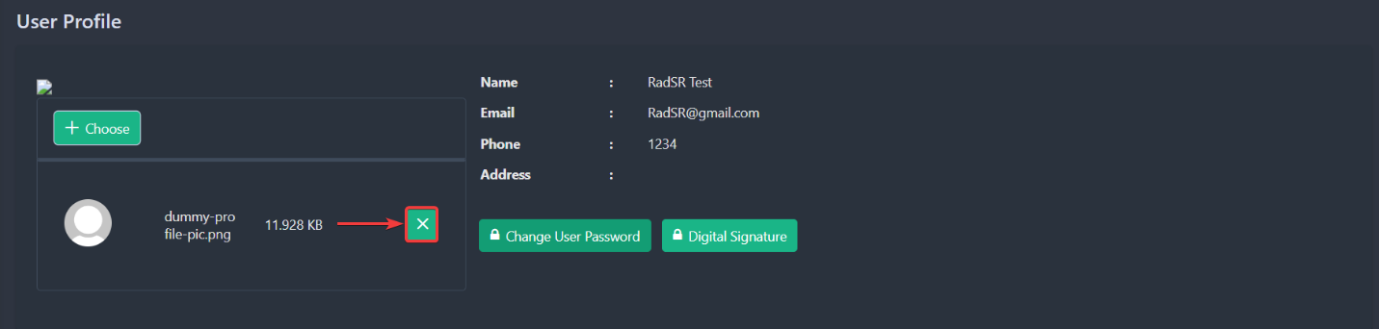

3.4.3 Adding Digital Signature
To add your Digital Signature, go back to your profile and click the Digital Signature button.
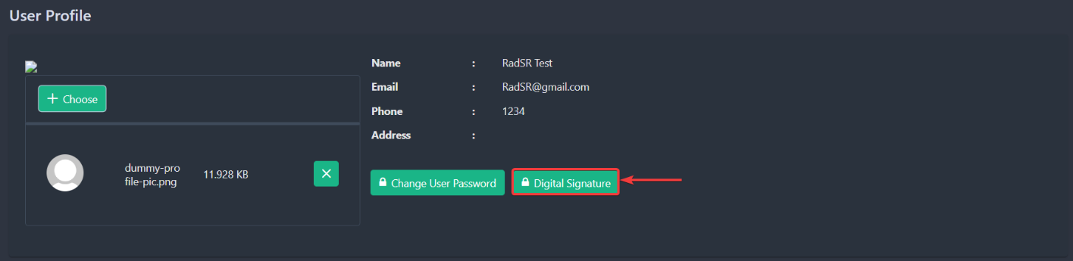

After clicking, you should see a new page where you will be able to upload your digital signature
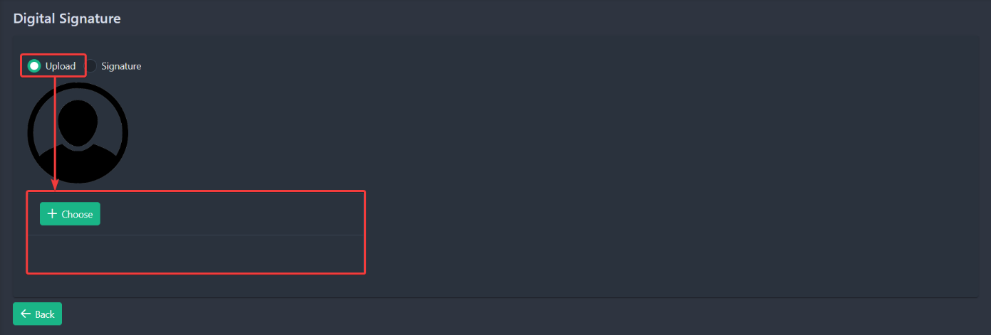

Or you can directly sign in the white blank section.
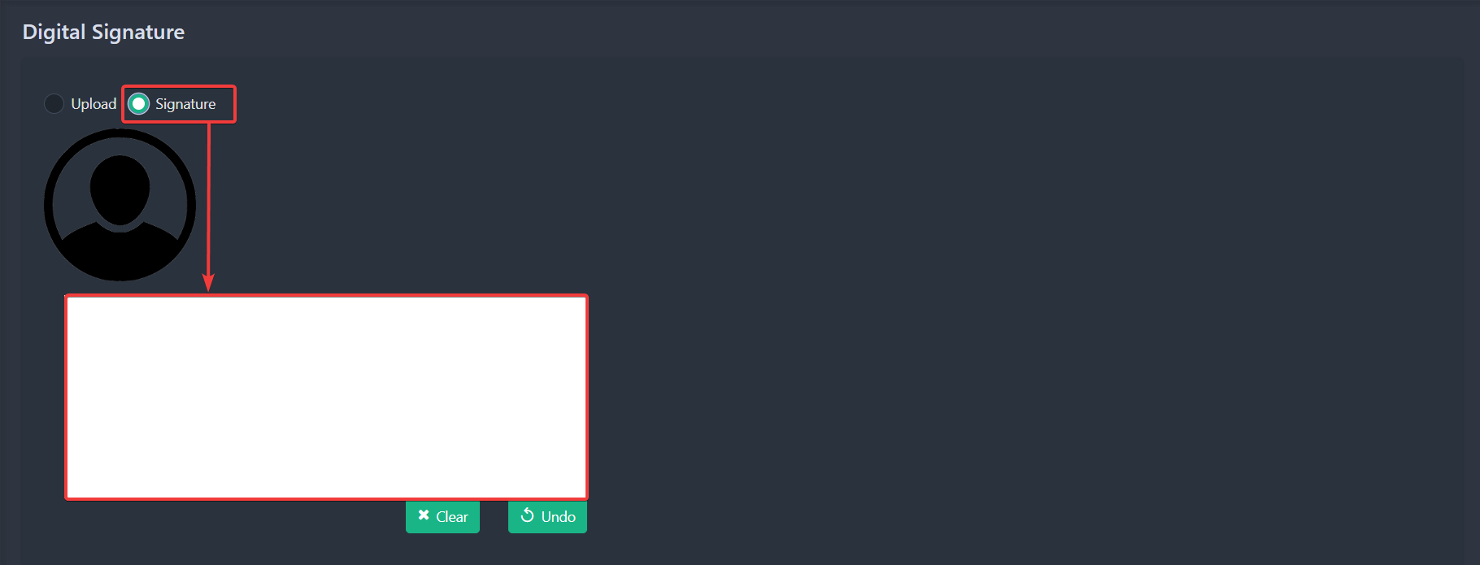

You can Clear your signature or undo a specific part of the signature by clicking on the Clear or Undo Button.

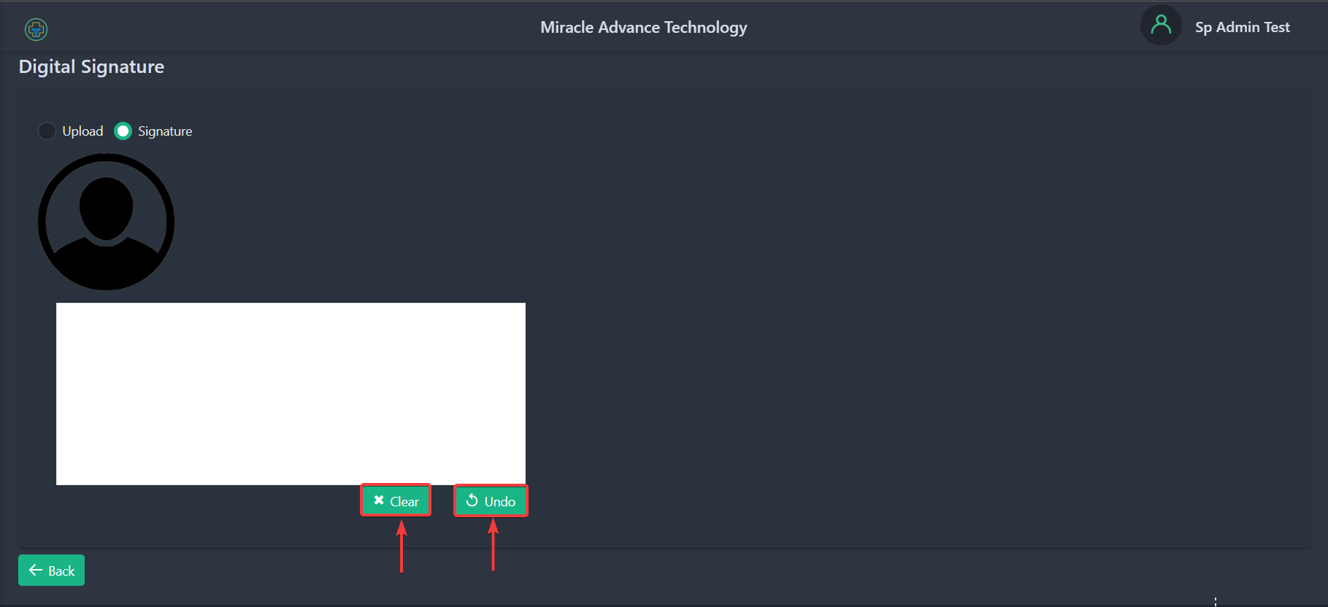

3.4.4 Exploring Finalized Workload
To add your Digital Signature, go back to your profile and in the bottom you should see a section called My Finalized Workload.
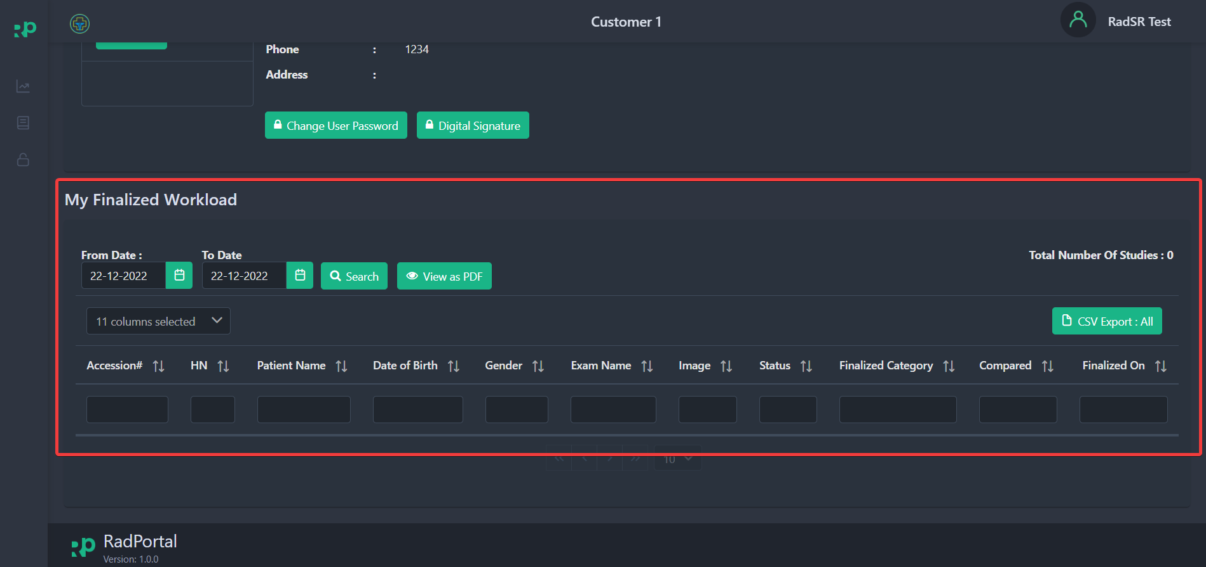

Now you can review a custom workload report by filtering the From Date [1] and To Date [2]. After selecting custom date range click on the Search [3] button.
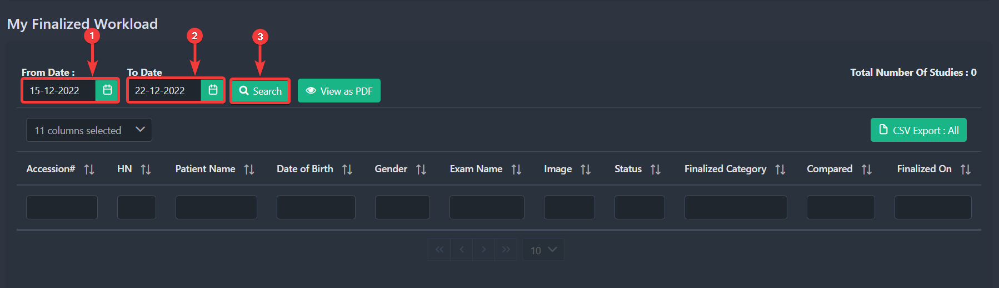

After clicking you should see your custom finalized workload list.

3.5 Sign Out from The System
To Sign Out from the RadPortal system, click on your username [1] in the top right corner and click on Sign Out [2].

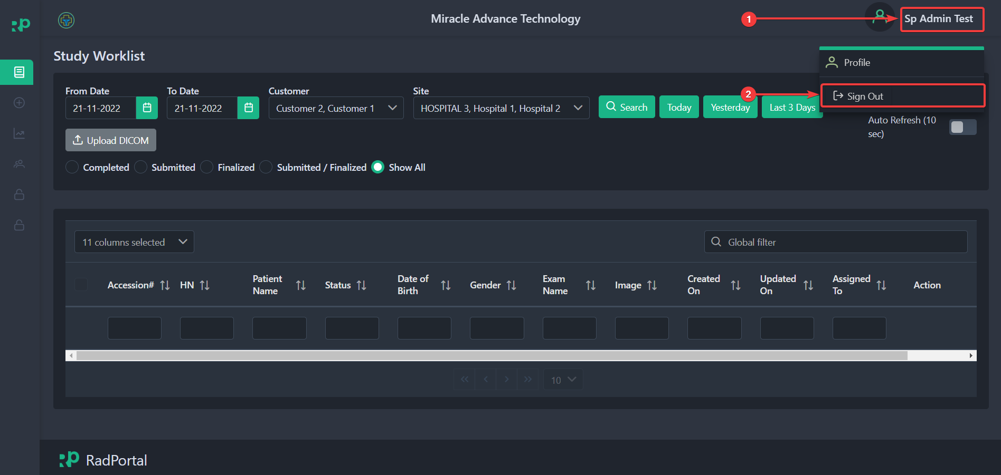

4. Exploring Dashboard
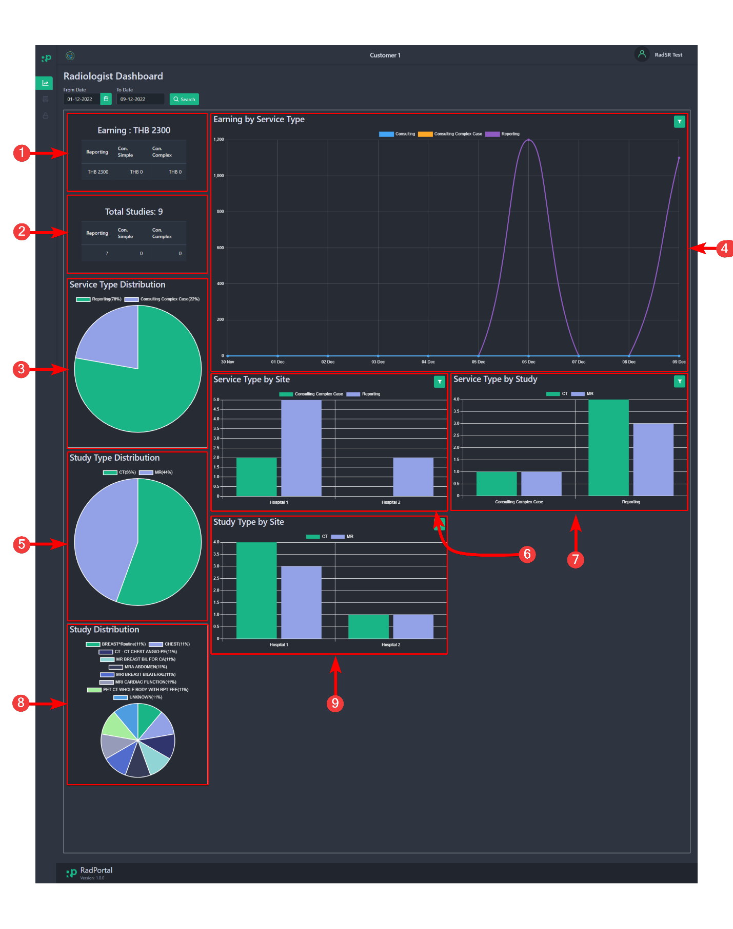

In the Radportal Dashboard, you will see a quick summary
1. Total Earnings
2. Total reports you finalized
3. Pie chart of service type
4. Total earnings by service type
5. Pie chart of study type
6. Chart of service type by hospitals
7. Chart of Service type by a study
8. Pie chart of Study distribution by modality

5. Exploring Worklist Menu
Study Workflow
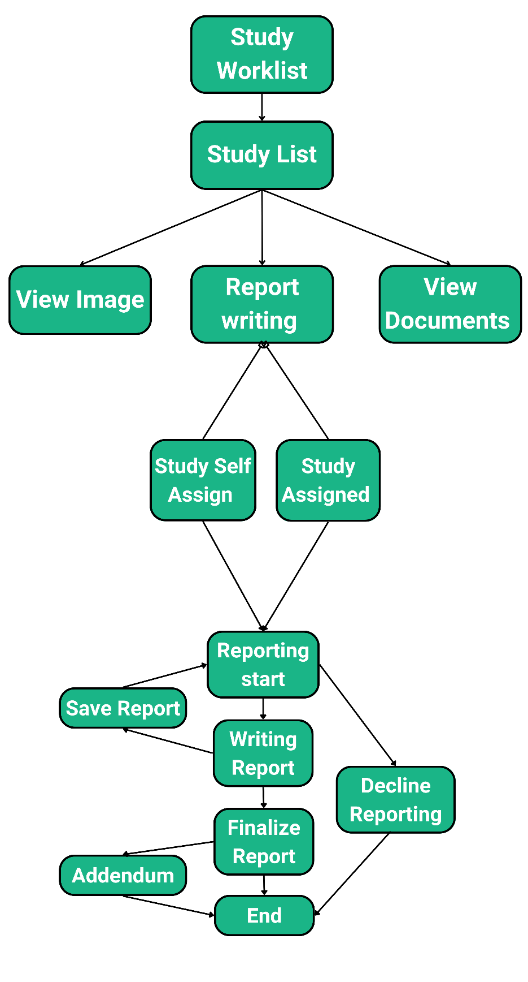

This menu in the RadPortal system allows you to keep track of studies that are assigned to you and all the studies that are kept open for any radiologist on the system. You can also view all modality test images in the Study worklist option. You can easily write reports for the studies that are assigned to you.
The worklist Menu page should look like the screenshot below. 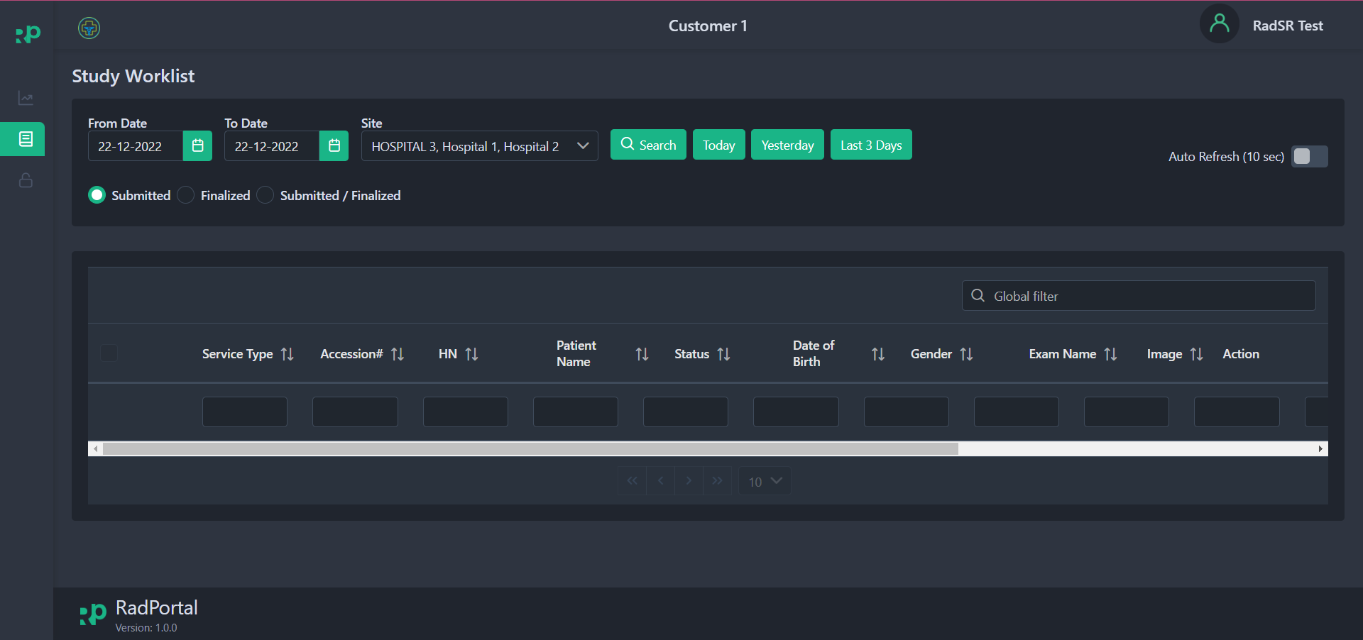

5.1 How to Search Studies
You can custom search based on criteria such as From Date [1], To Date [2], or you can also search by selecting a specific Site or Hospital [3]. Finally, click on the Search [4] button.
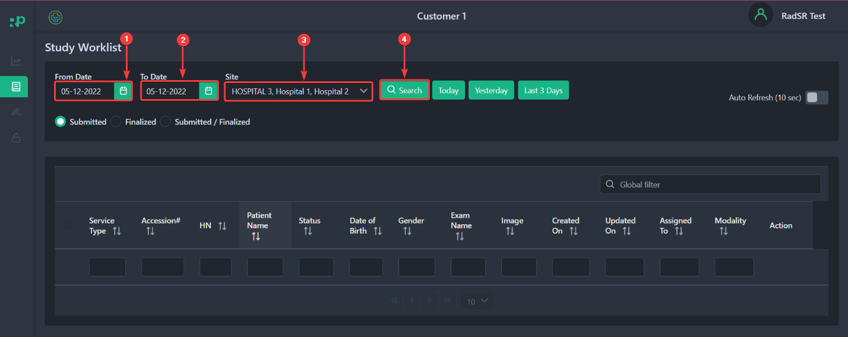

After clicking, you should see all studies/cases that match your custom criteria.
You can even see all studies/cases created Today [1], Yesterday [2], or in the last 3 days [3].
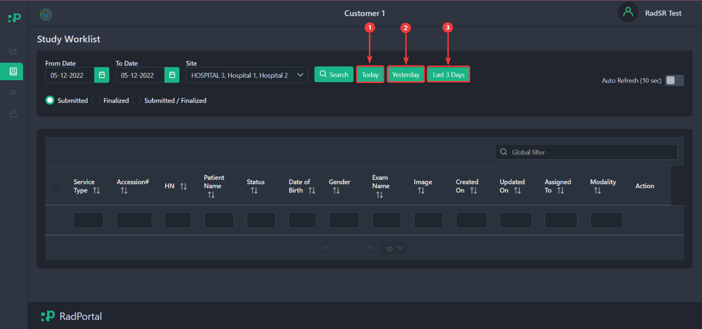

5.2 How to Sort Studies
You can easily sort study-list based on status, such as Submitted [1], Finalized [2], or both Submitted and Finalized [3]. To sort studies, click on the radio button that you see before each status section.
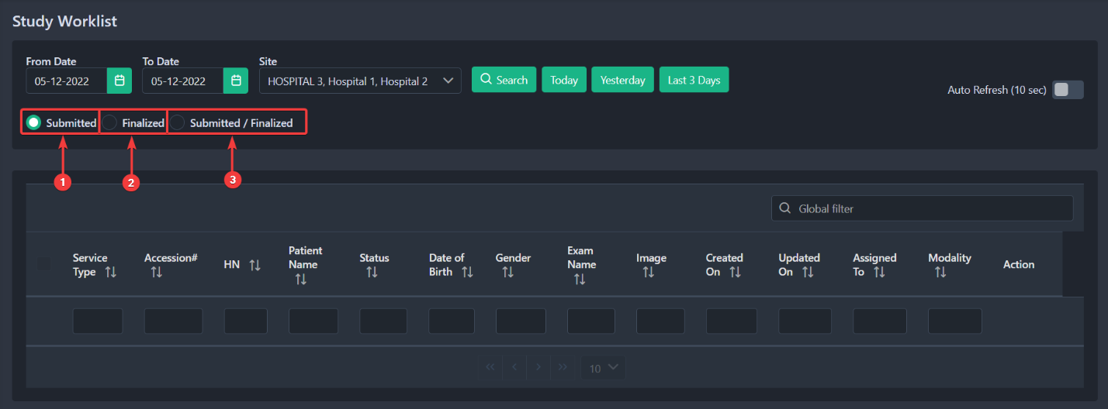

You can enable auto-refresh by clicking on the auto-refresh slide button. After enabling auto-refresh, the page will refresh continuously after every 10 seconds.
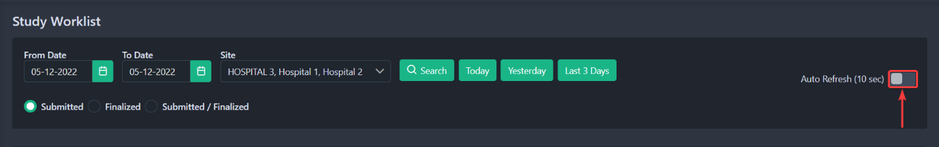

5.3 How to view Images, Decline Cases, write Reports, and View Additional Documents of Studies

On the Study Worklist page, you can only access the studies that are left open for all radiologists or specifically assigned to you. You can review Images of these studies, add reports, Finalize your report, and add Addendums after finalizing studies or you can decline assigned cases before you finalize your report. You can view additional documents that are attached to the studies.

5.3.1 Review Images of a Specific Study
You can easily access all images of a specific study by clicking on the Image Icon in the screenshot below.
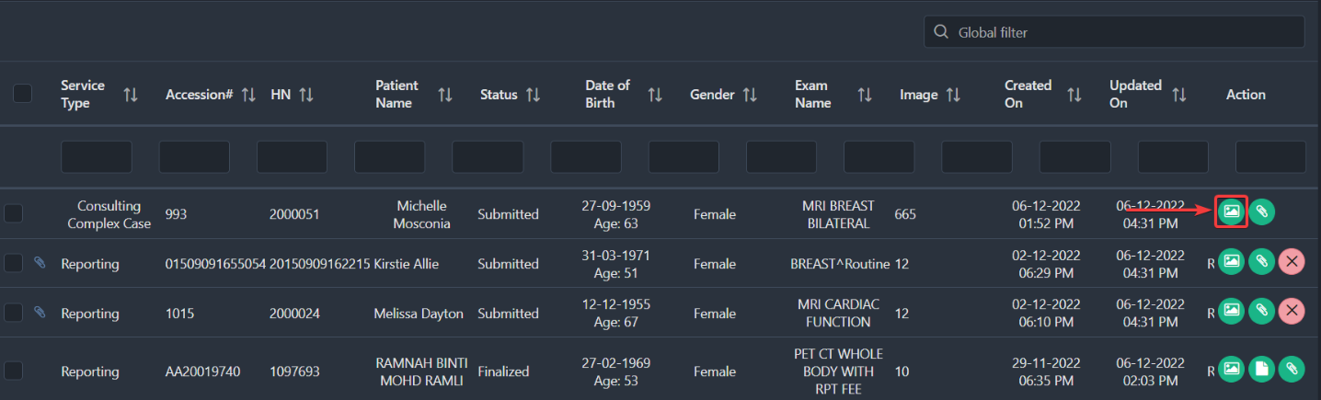

After clicking, you should see a popup window where you must sign in with a specific Username [1] and Password [2]. This step ensures that only authorized personnel can view the medical test images. Finally, click on the Sign In[3] button to sign in.
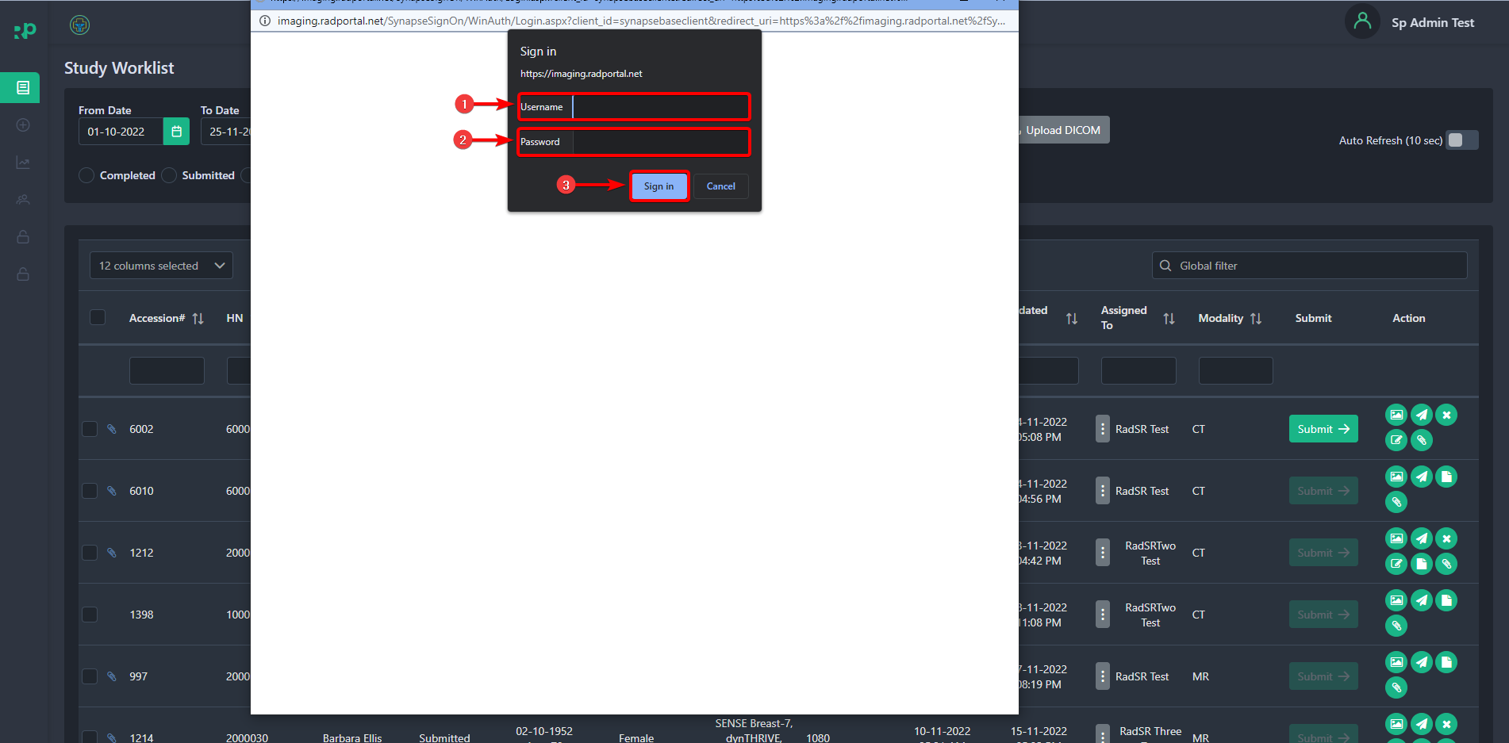

After successfully logging in to the system, you should be able to see all the test images of that specific Patient's medical test.
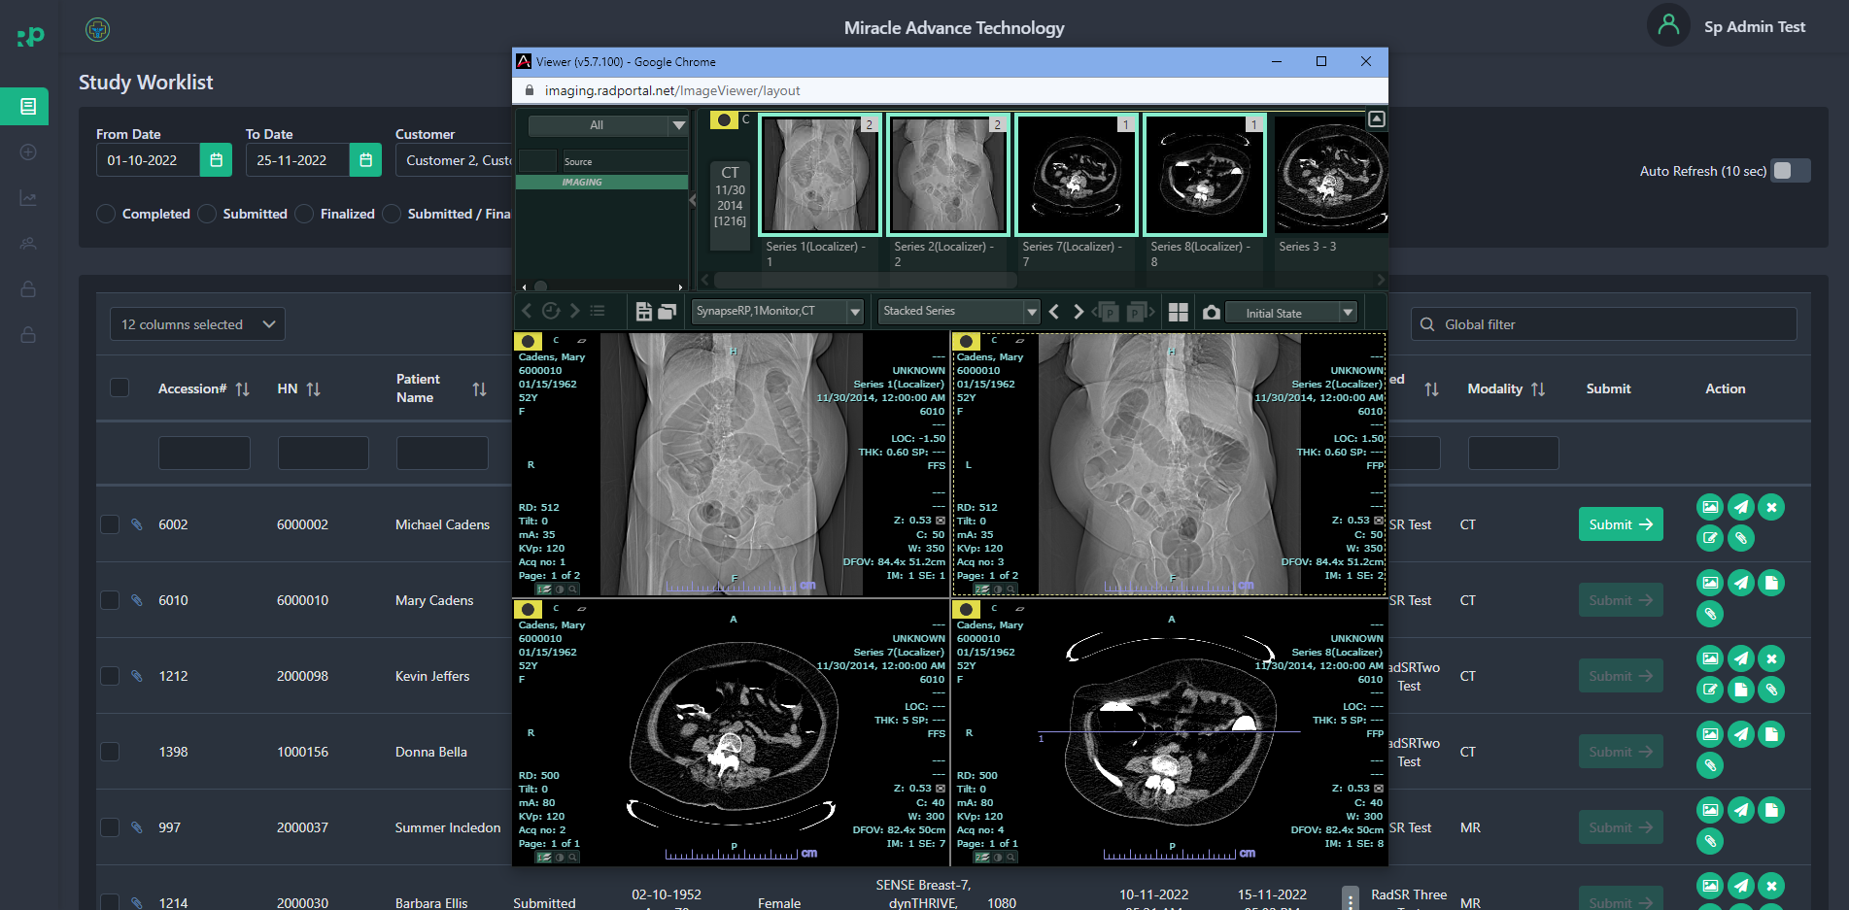

5.3.2 How to Decline Assigned Studies
If a hospital has assigned a study/case to you, then you should see the study/case on the study worklist page. To decline an assigned case, click on the Cross Button.
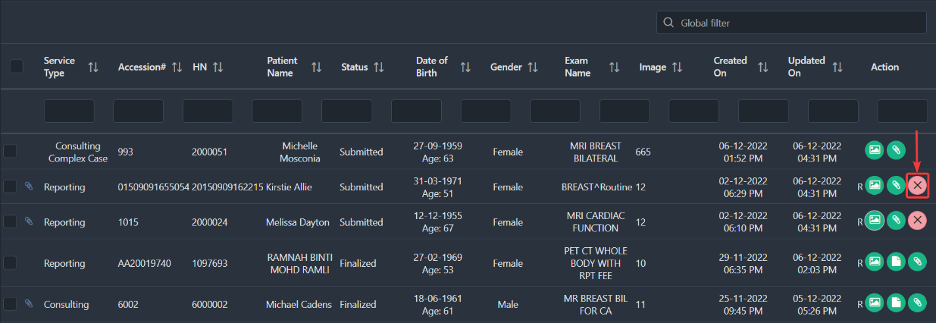

After clicking, you should see a confirmation popup window. You can click the No [1] button to stop the decline process and take you back to the study worklist page. Click on Yes[2] button to decline the case.
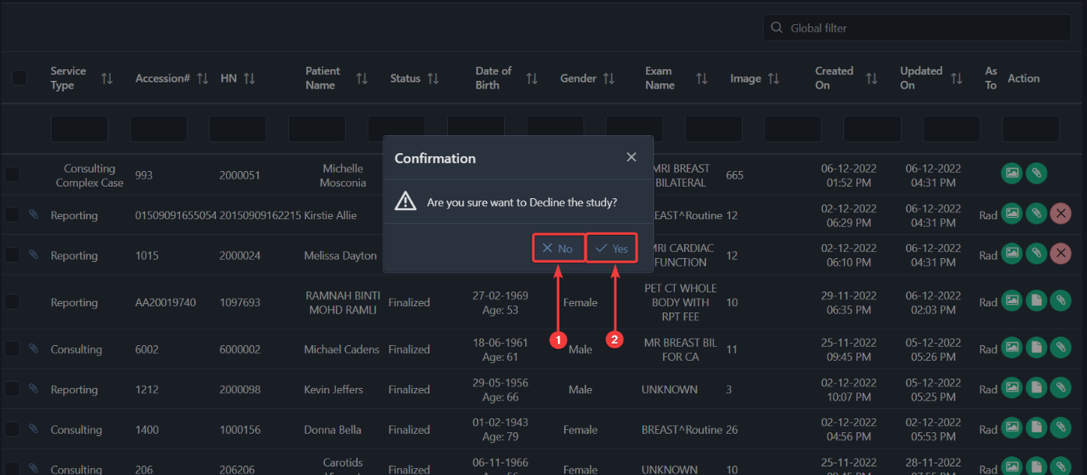

Another way you can decline a study is by double-clicking on your preferred study/case. After double-clicking, you should see two popup windows.
In one of the windows, you will see a Decline button. Click on the Decline button to decline that specific study. 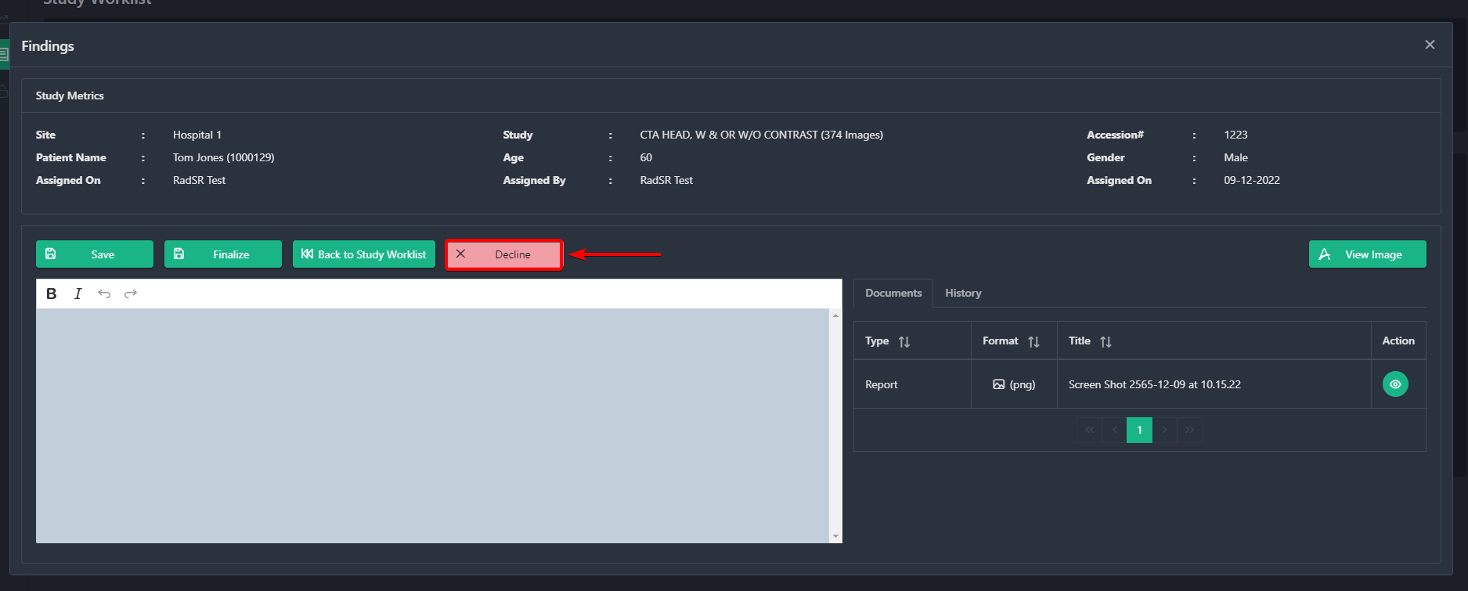

5.3.3 How to View Additional Documents of a Study
You can view any additional documents attached to open studies or specifically assigned to you. To review documents, you have to click on the Paperclip Icon.
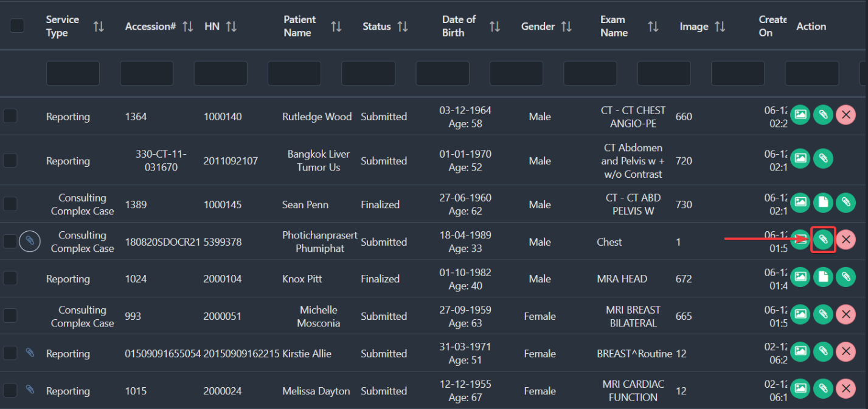

This paper Paperclip icon indicates that this specific study has additional documents attached to it.
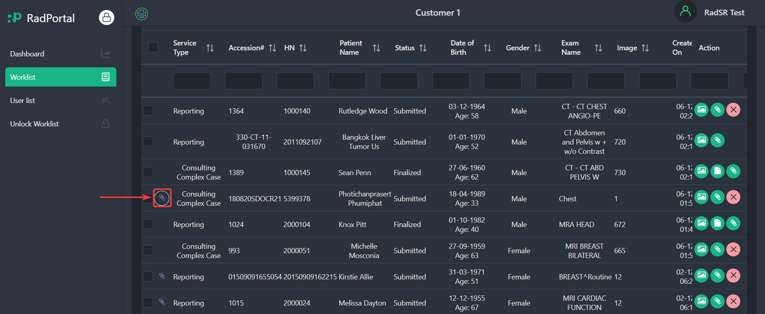

5.3.4 How to Write Reports and Finalize Reports
After a hospital has assigned a study/case to you or you see an open case/study, you can write a report for these cases. To write a report, you have to double-click on your preferred study/case. After double-clicking on the case, you should see two popup windows.
The first window lets you review all the images of that particular study/case.
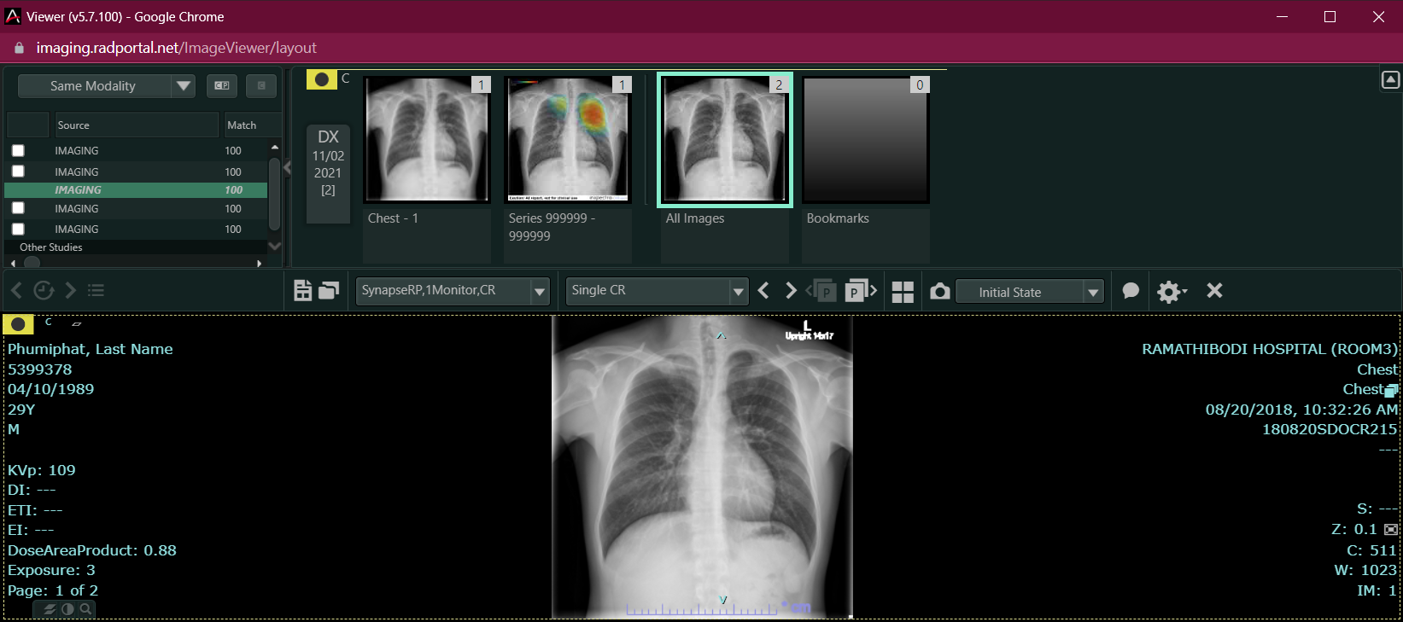

And on the second window, you can write a report in the blank section.
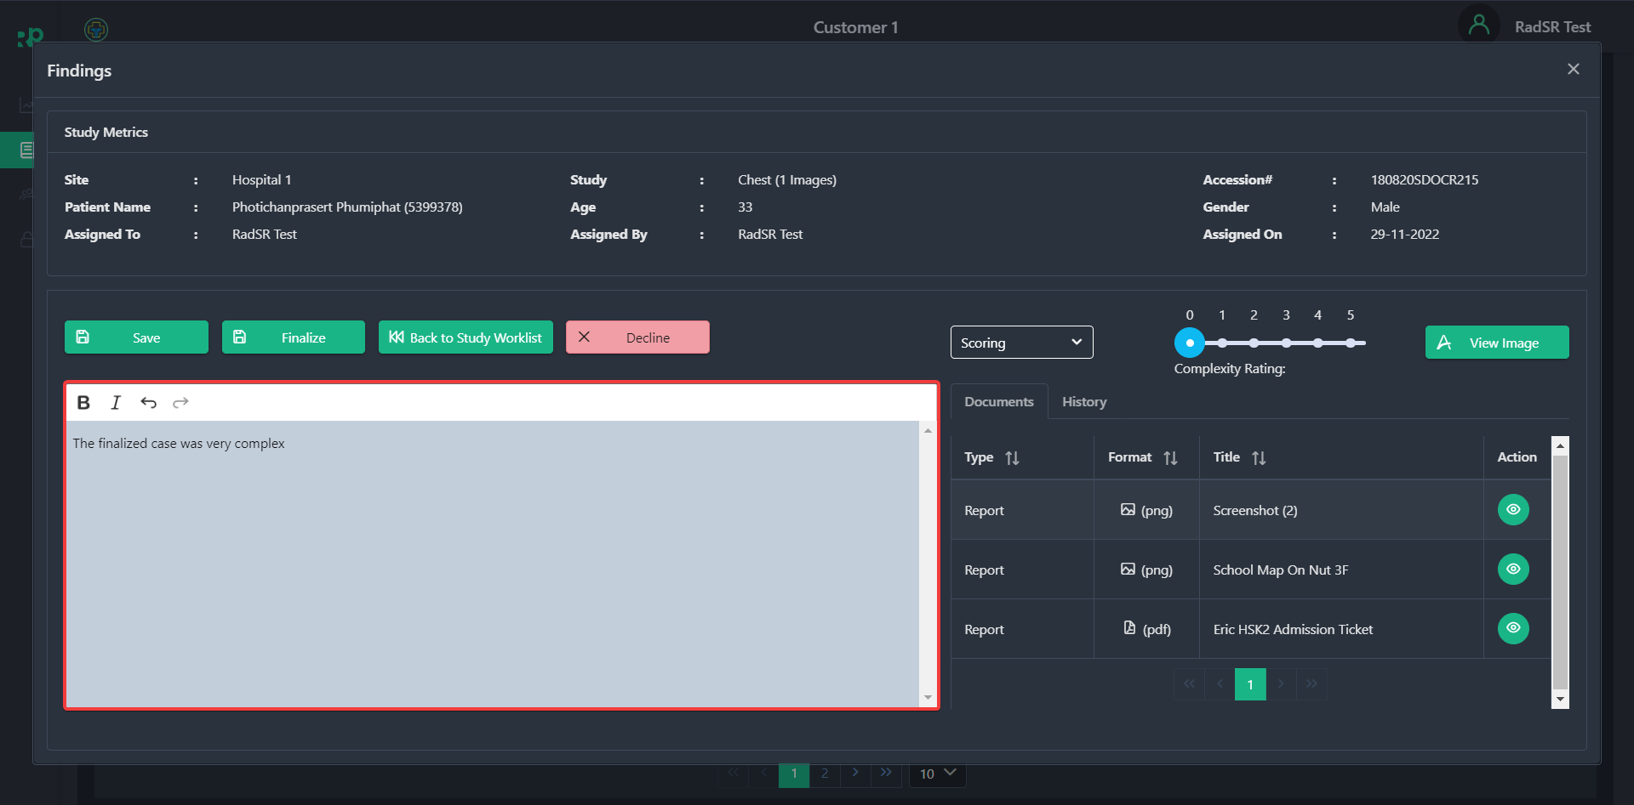

After writing your report, you can just save the report and come back to it later by clicking on the Save [1] button, or you can finalize the report by clicking on the Finalize [2] button. After finalizing your report, you can not change it afterwards. To go back to the Study worklist page, click on the Back to Study Worklist [3] button.

If you do not want to take on the study/case, then you can decline it by clicking on the Decline [4] button. On this page, you are also allowed to view all images.
To view images, click on View Image [7] button.
On this same window, you are allowed to provide Scores and Ratings based on the type of the study/case. You will not be able to see these two options if the case/study is
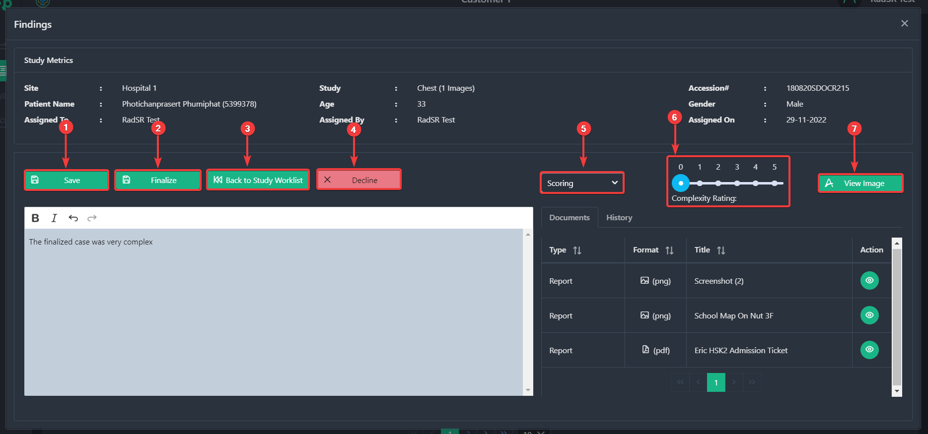

NOTE: You only can provide scores for Consulting Simple studies. You can provide both scores and complexity ratings for Consulting Complex studies.

On this window, you can access all additional documents attached by hospitals.
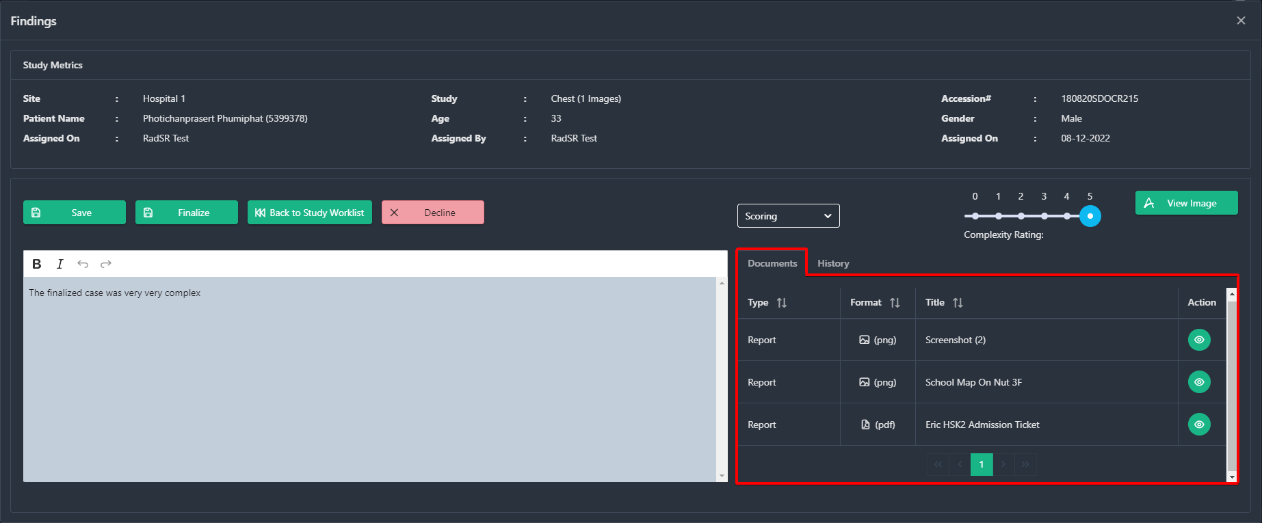

To review the document, click on the Eye Icon.
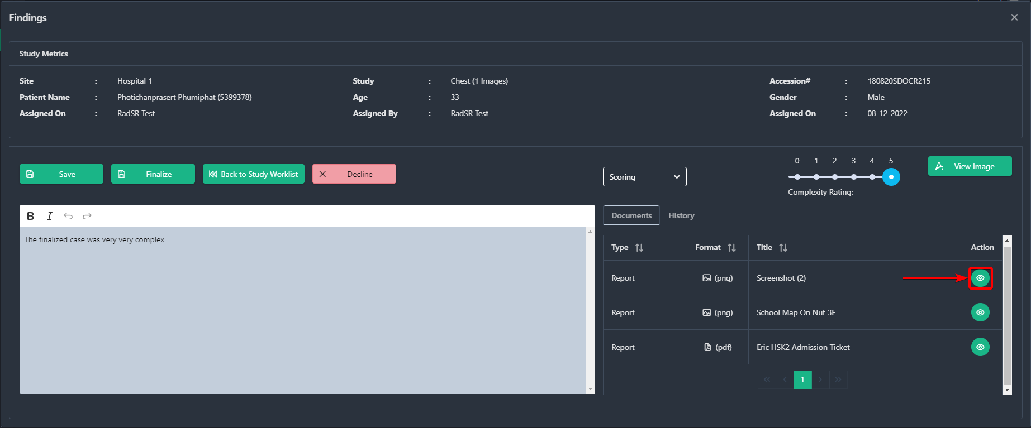

You can also see patient test history by clicking on the History tab.
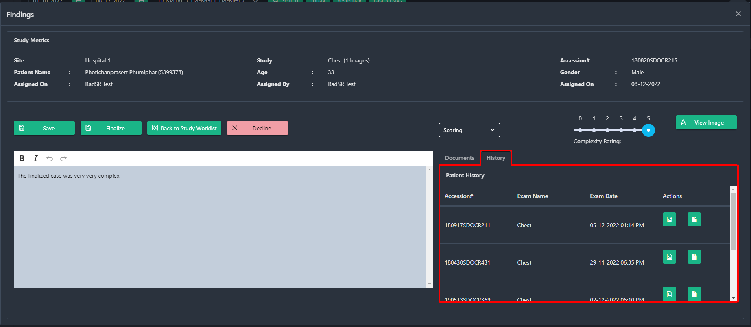

In the history option, you can review Information such as Accession, Exam Name, and Exam Date, and under Actions, you can check history study images and previous Finalized reports.

To review Images of previous studies, click on the File icon. 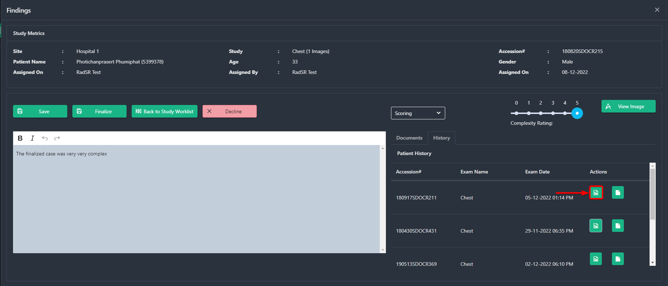

To review Finalized Reports of previous studies, click on the File icon.
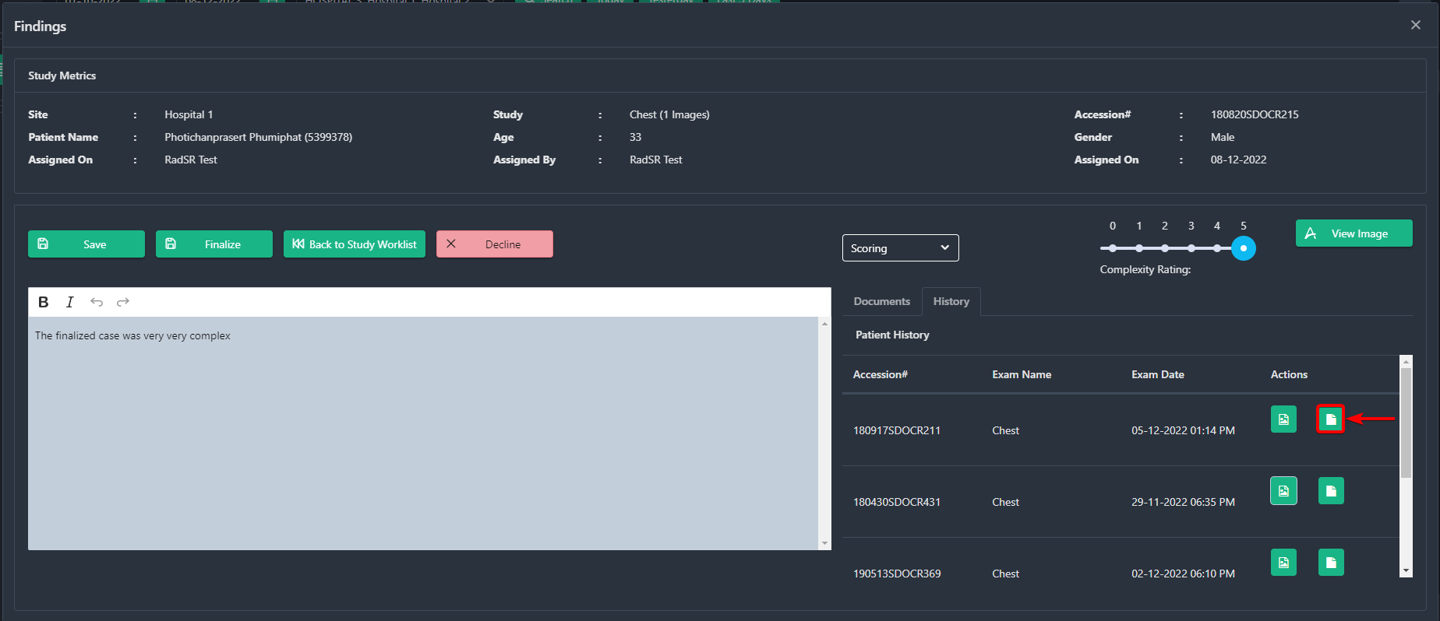

If you save your unfinished study you will see a status Draft in the upper section of the status. The studies that have the draft status can be editied again
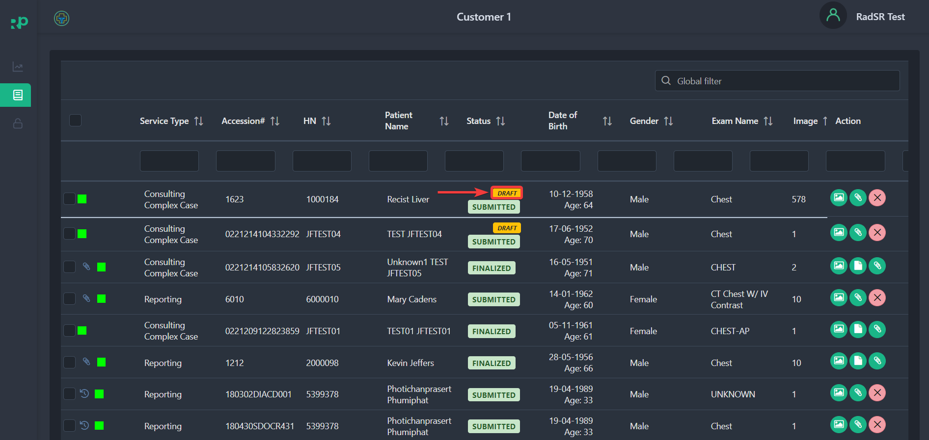

5.3.5 View Study Reports
After you have finalized a report of a study, you can view it by clicking on the File Icon

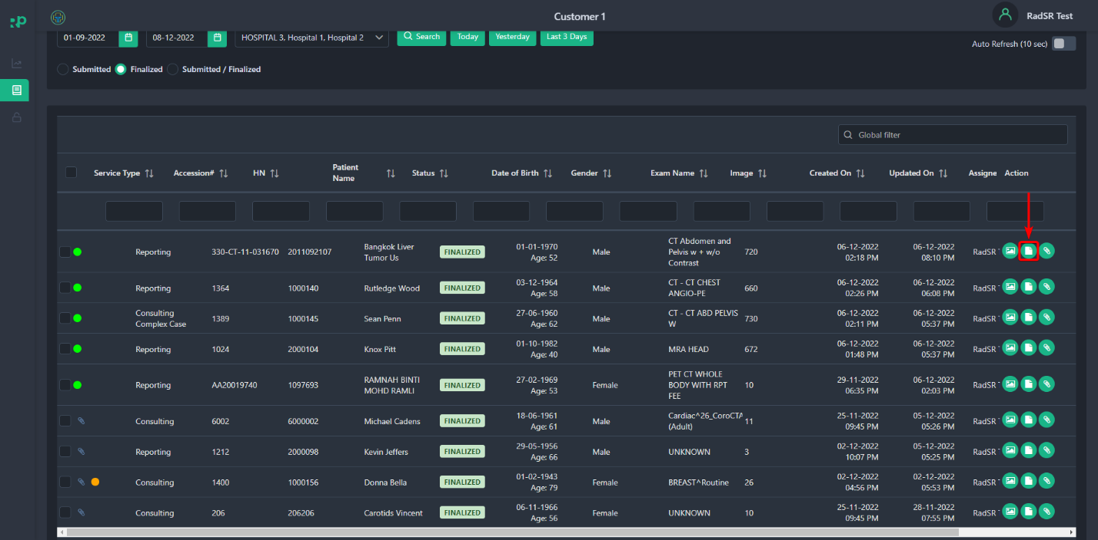

5.3.6 Adding an Addendum
You can add information to your finalized report by writing an addendum. To write an addendum double, click on any finalized study/case.

After the study loads, you will see the Addendum button.
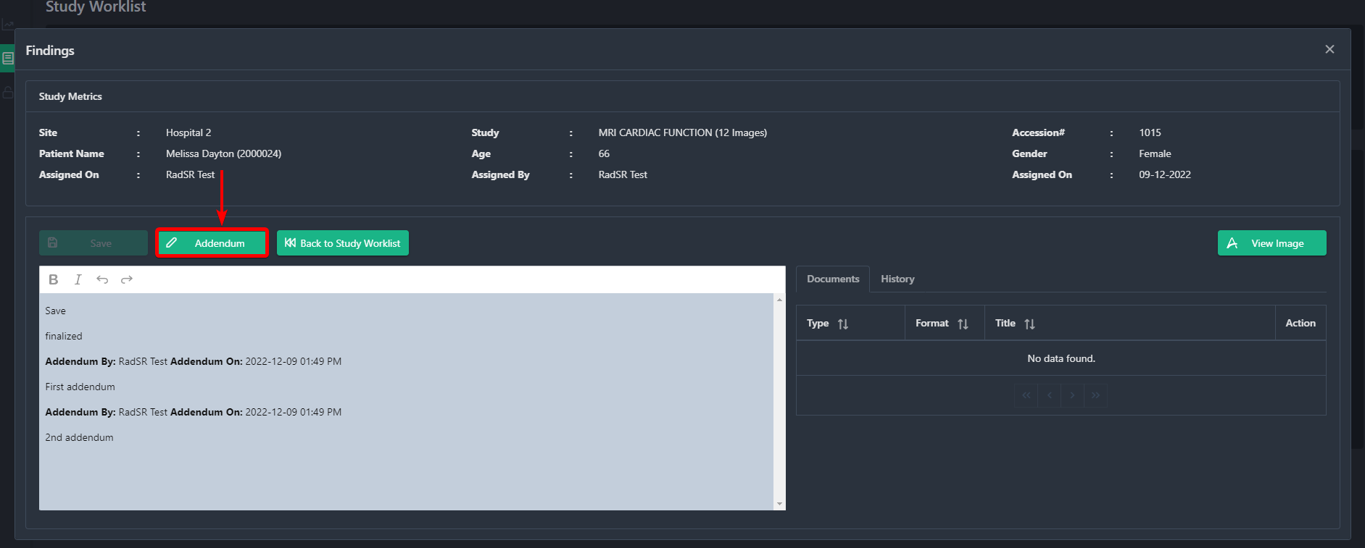
After clicking on the Addendum button, you should see a popup when the system shows you the previous Finalized Reports and Addendums [1] and a Blank [2] section where you can add the new Addendum.
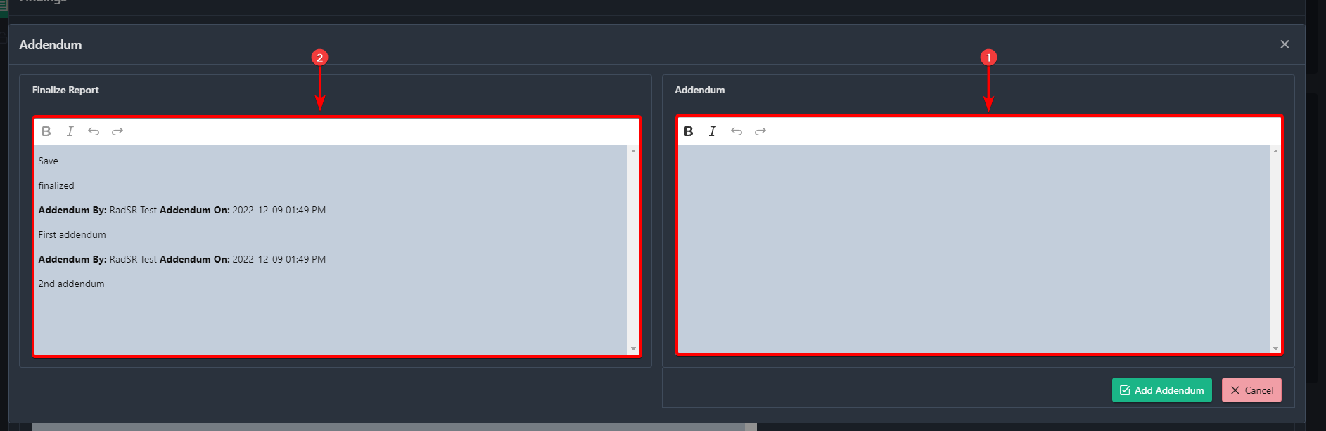

You can bold and italicize your addendum texts by clicking on the B [1] and I [2] icons.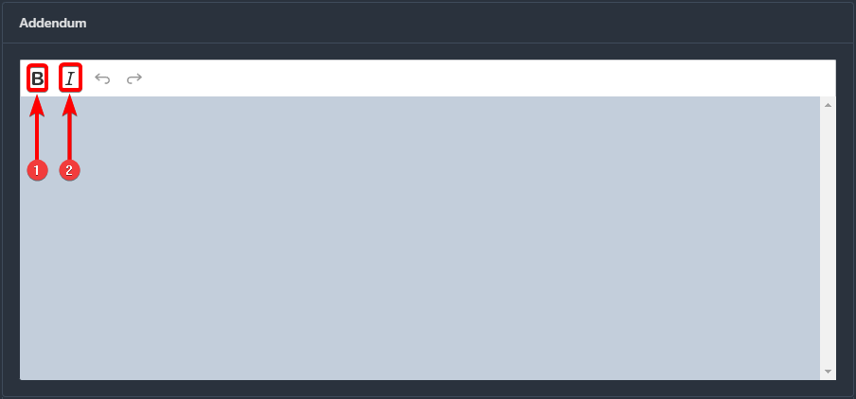

You can undo your edits by clicking on the Undo [1] icon and redo edits by clicking on the Redo[2] icon.
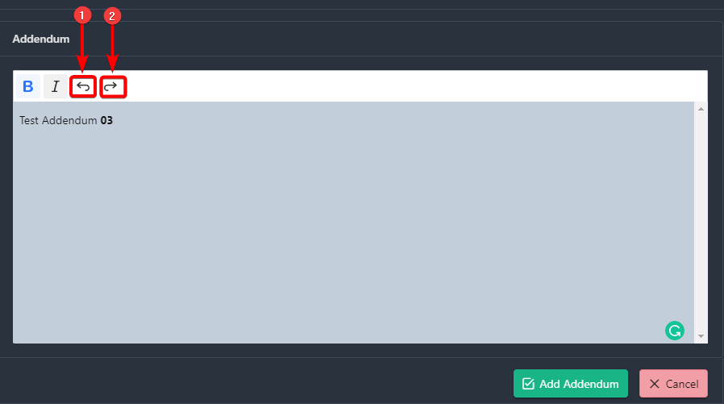

Finally, when you are done with the Addendum, click the Add Addendum button.
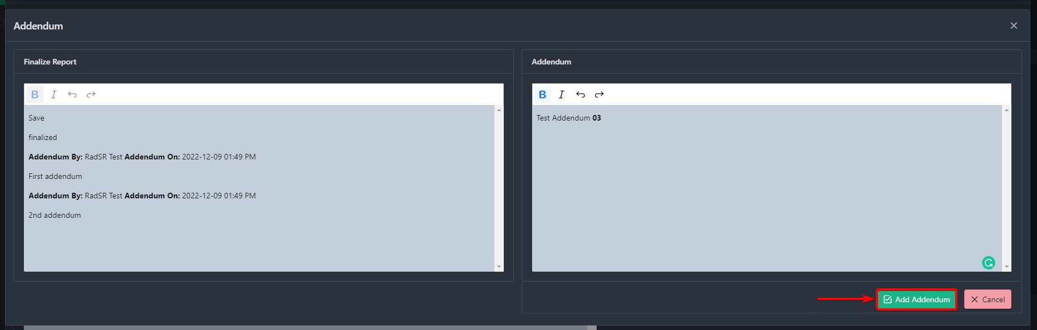

NOTE: You can not edit the Addendum again after clicking the Addendum button.

Now the system will take you back to the previous page, where you can review all addendums along with the Information about who added them and the date they were created.
